KS3: Scratch
Introduction to programming

Last updated: November 2017 (ER)

Name | Group | Target grade
What went well:
Even better if:
Student feedback:

Progress check - Beginning of unit
- I understand.
- I kind of understand.
- I don’t understand.

Objective 1: Introduction to the Scratch Programming environment
I can…
Create new code
Edit existing code
Save a scratch file
Open a scratch file

Objective 2: Loops
I can…
Create a Repeat Loop
Create a Forever Loop

Objective 3 – Conditional
I can…
Create an IF (conditional) statement
Create an IF ELSE (conditional) statement
Create a nested IF (conditional) statement

Objective 4 – Variables
I can…
Create a variable
Assign a value to a variable
Change a value in a variable

Objective 5 – Comparison operators
I can…
Use a greater than
Use a less than
Use an equals

Scratch
The aim of this unit is to give students an introduction to programming using a visually friendly drag and drop programming environment. Students will complete up to 7 different projects learning and relearning a range of programming techniques.

By the end of this unit you will:
- Understanding the programming concepts: sequencing, iteration and selection
- Understand how to create and use a forever loop and a repeat loop
- Understand how to create and use a IF, IF ELSE and nested IF statement
- Understand how to create and use a variable, including assigning a new value to it and changing an existing value
- Understand how to create and use a comparison operator such as <, >, or =

Projects
- Project 1 – Chase
- Project 2 – Eyes
- Project 3 – Racing Cars
- Project 4 – Helicopter
- Project 5 - Tanks
- Project 6 - Space invaders
- Project 7 - Asteroids

Project 1: Chase
For this objective we will learn about:
- Forever loops
- IF (Conditional) statements

Step one:
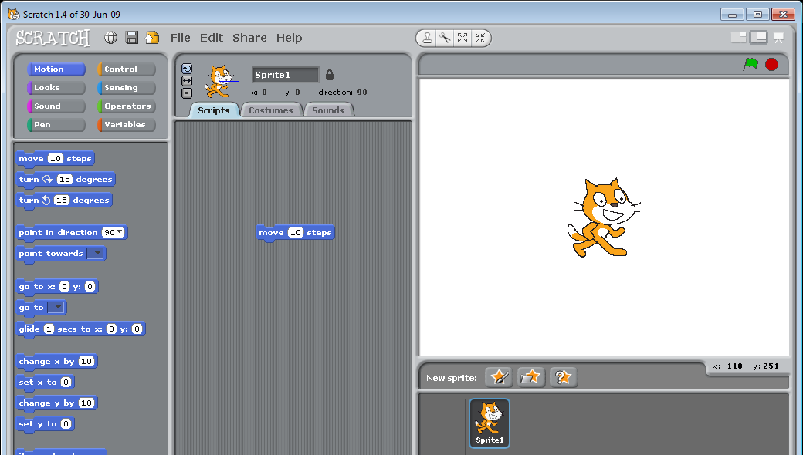
- Start off by selecting Sprite1 and then setting a motion so that the cat moves forward 10 steps

Step two:
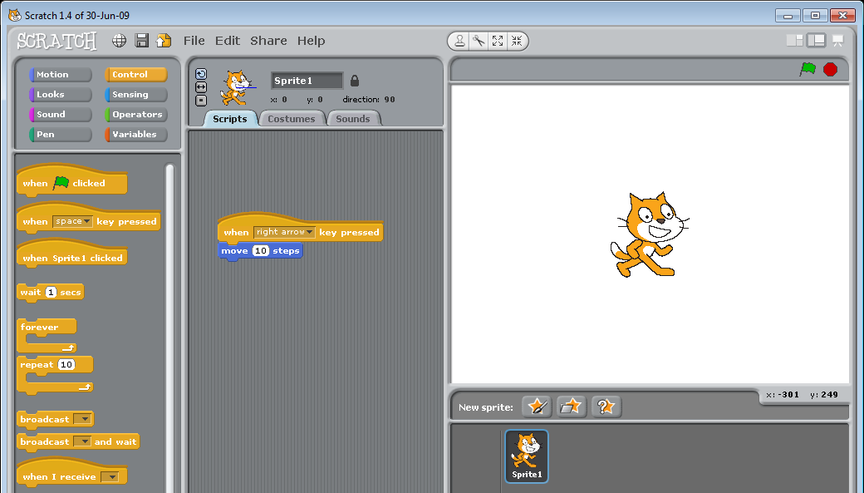
- Now lets set the motion to start when the user click ths right arrow

Step three:
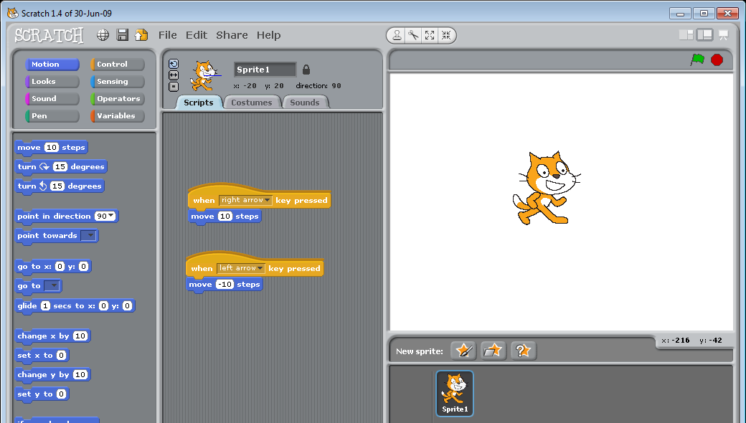
- Now set a motion so that the cat moves backward 10 steps when the left arrow is pressed

Step four:
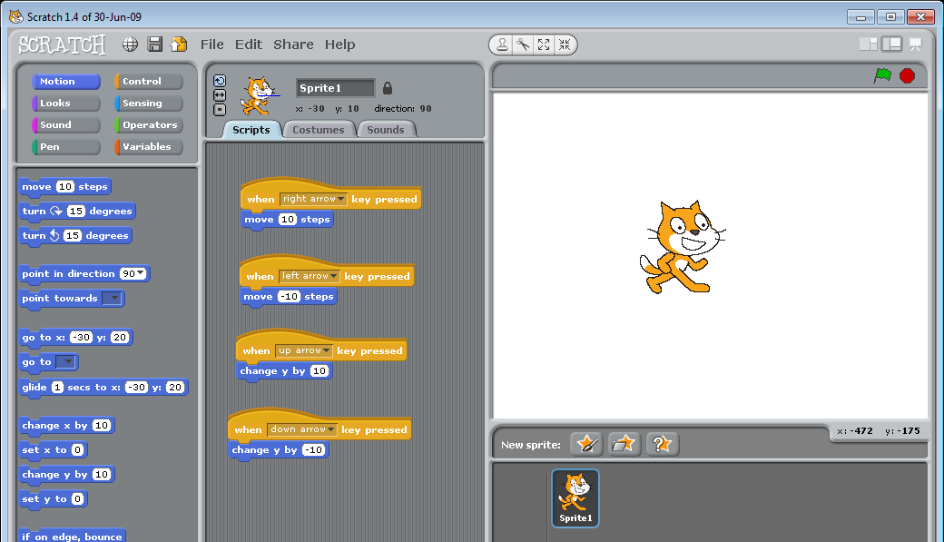
- Moving up and down is a little different. Just like on a graph when you have X & Y we’ll use this to make the sprite1 go up or down.
- Add a motion so that the cat moves up 10 steps when the up arrow is pressed
- Add a motion so that the cat moves down 10 steps when the down arrow is pressed

Step five:
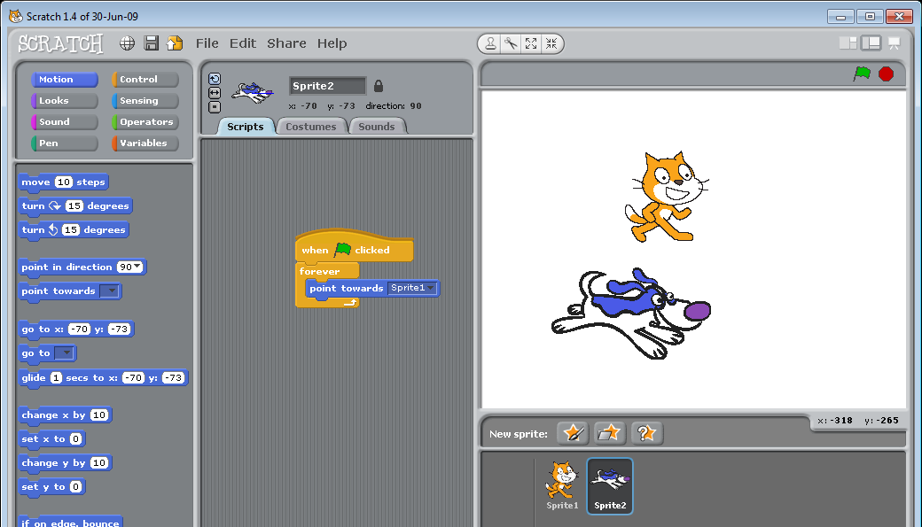
- Insert a new sprite by clicking 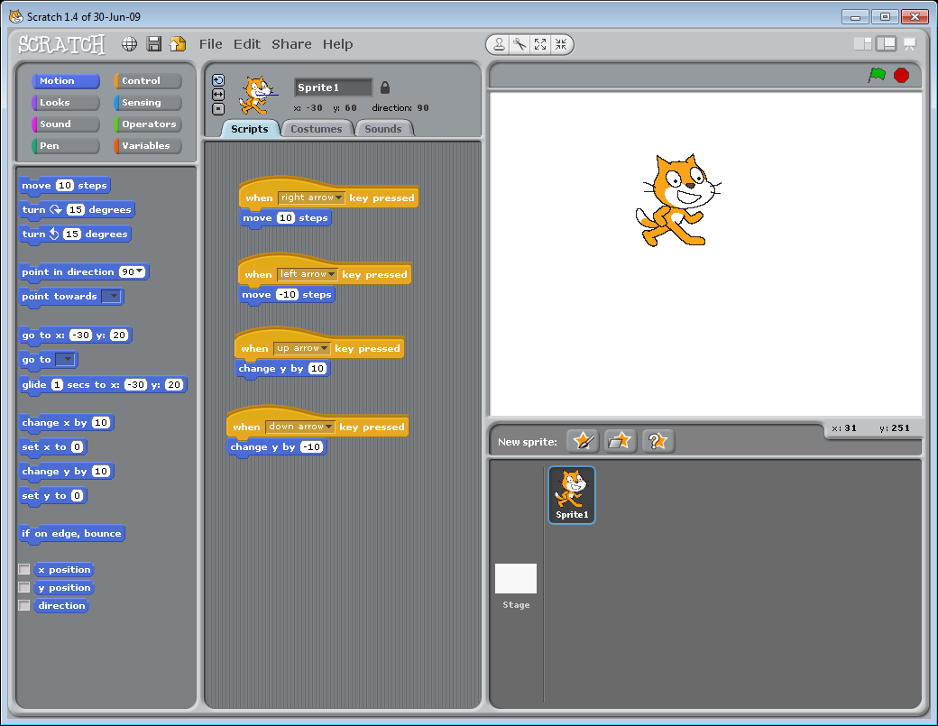
- In the animals folder click and select dog1-a and click OK
- Add a script to sprite2 so that the dog always looks at the cat: When the green flag is clicked forever point towards sprite1

Step six:
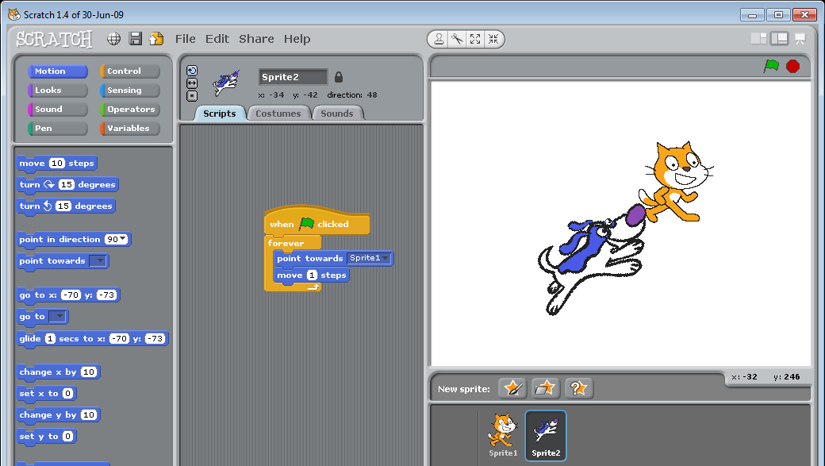
- Now lets get the dog to move towards the sprite
- Add a script to sprite2 so that the dog moves 1 step towards the cat
- (note that if you want the dog to move quicker make the number of move steos higher!)

Extension: Step seven:
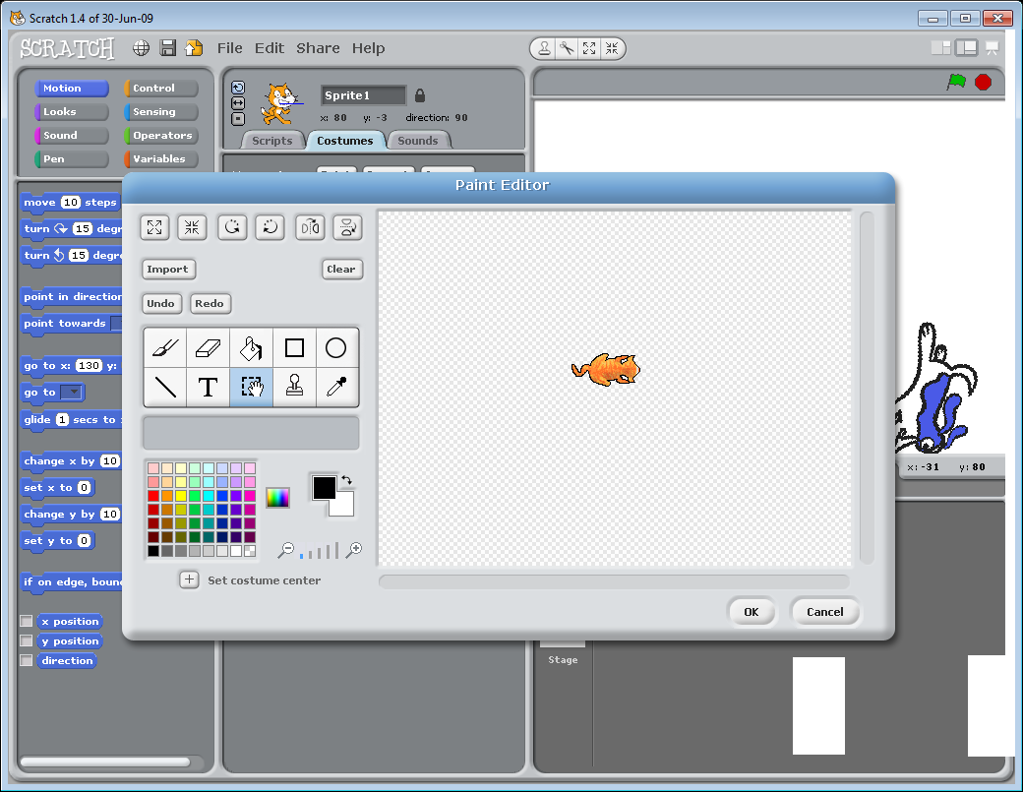
- Lets change how Sprite1 (the cat) looks. Lets change the appearance of the cat and make him a bit smaller.
- To edit the cat, click the costumes button. You’ll see there are several costumes but we’ll be editing costume1.
- To change the appearance of the cat you can edit him using the paint tools on the left hand side of the window. We’ll be completely changing him so click clear canvas
- Now select import. Find cat2 and select ok
- Press the shrink button a few times so that the cat is smaller.
- Now click OK
- Now make your dog a bit smaller too. (make sure you make him smaller the same number of times!)

Extension: Step eight:
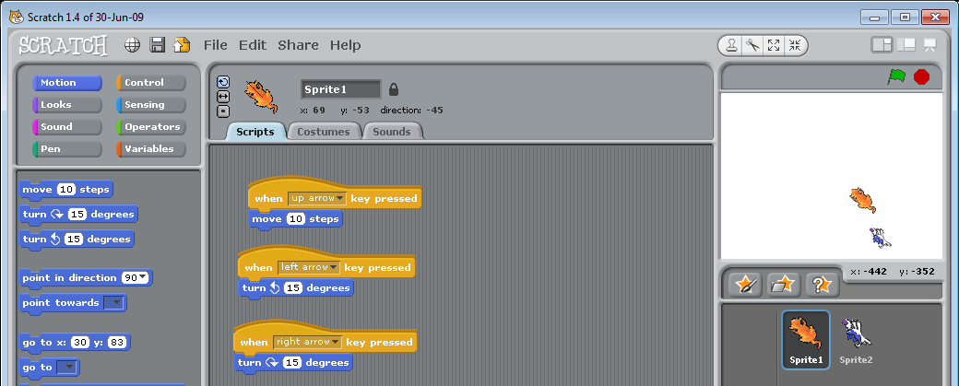
- You’ll notice that the cat looks like he is running backwards and the dog looks (sometimes) like he is running updside down. Try setting a new script for sprite1 (the cat) so that when you click left ot right he rotates instead of moves.
- Select sprite1
- Delete all the scripts for sprite1
- Add the following scripts:
  - When the up arrow key is pressed move 10 steps
  - When left arrow key pressed rotate left 15 degrees
  - When the down arrow key is pressed move -10 steps
  - When right arrow key pressed rotate right 15 degrees

Extension: Step nine:
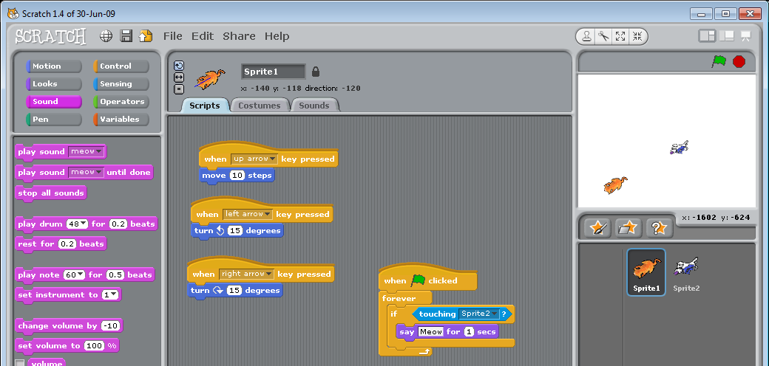
What if the dog captures the cat? Let’s set it so that when the dog dows finally capture the cat, the cat meows.
- Select Sprite1 (the cat) and go into the sensing section
- Add the following script to sprite1: When green flag is clicked forever if touching sprite2 say Meow for 1 seconds

Extension: Step ten:
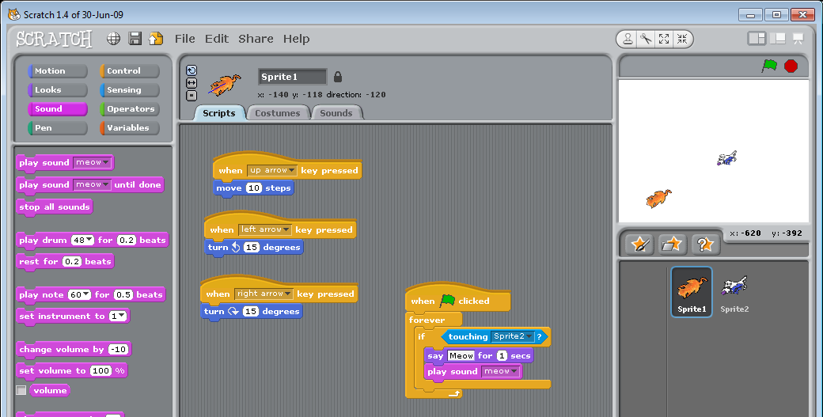
- Now lets set the cat to make a sound when the dog gets it

Project 2: Eyes
For this objective we will learn about:
- Forever loops
- IF (Conditional) statements

Task 1
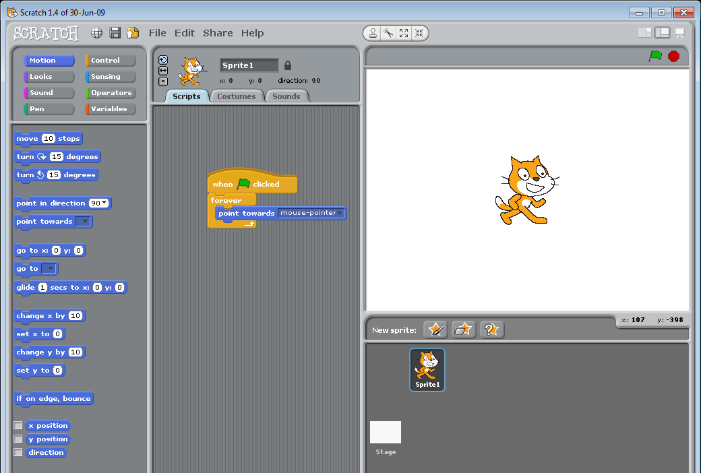
- We’ll start off by adding a script to Sprite1.
- When the green flag is clicked, forever point towards mouse-pointer.
- Press the green flag and watch how the cat always faces the mouse pointer.

Task 2
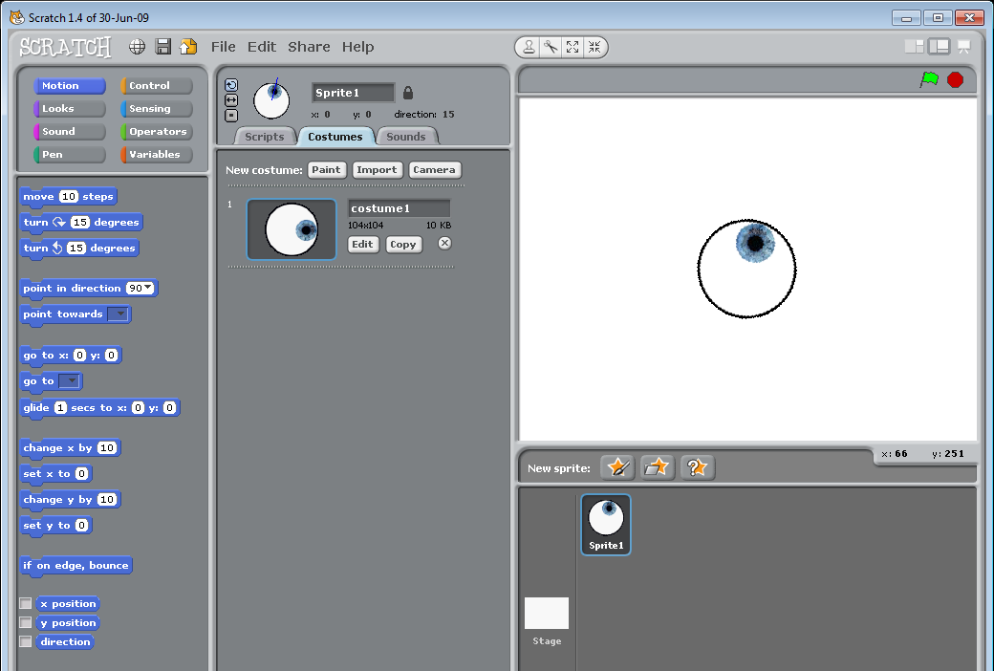
- Now we’ll change the picture of the cat and replace it with an eyeball
- On sprite1 go to costumes and delete costume2.
- Now click edit on costume1 and click clear
- Now select import and navigate to where you downloaded and saved the eye and click ok and then ok again
- Now when you click the green flag the eye looks at your mouse pointer.

Task 3
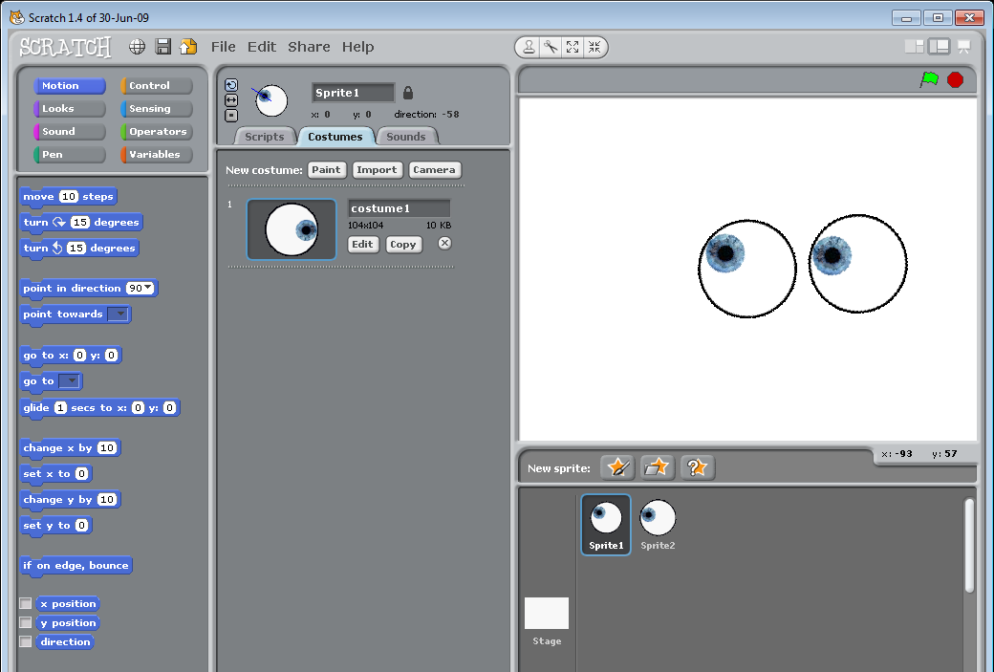
- Now we’ll duplicate sprite1 so that we have 2 eyes
- Right click on sprite1 and click duplicate
- Position the eyes so that they are next to each other
- Press the green flag and they should both now look at the mouse pointer

Task 4
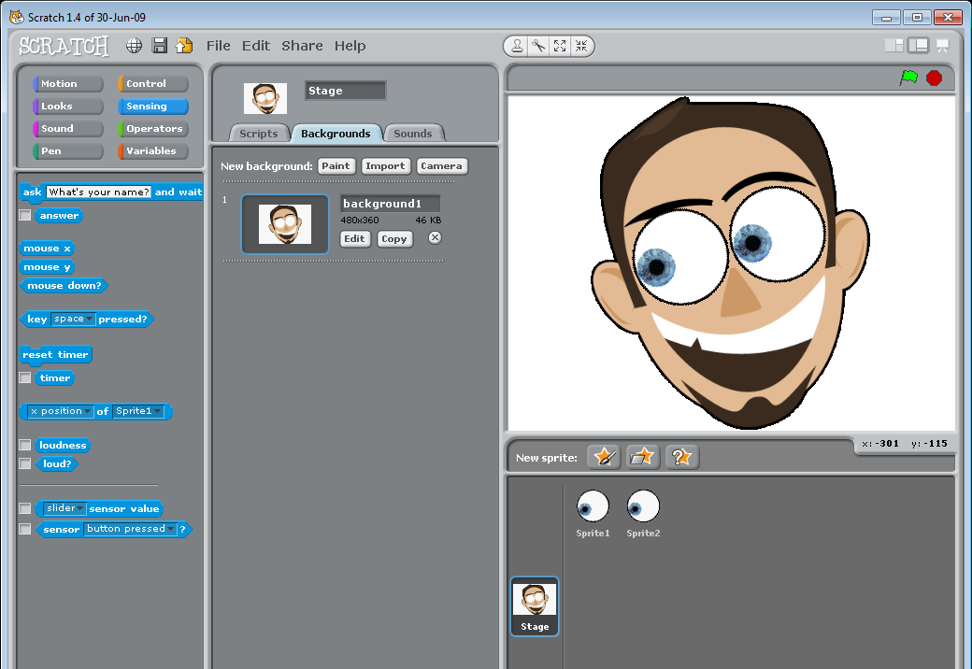
- We’ll change the background now to something a little more appropriate.
- Click stage and then go to backgrounds and then edit
- Click import and then navigate to where you downloaded and saved the face and click ok, then ok again
- Place the eyes in the right places on his face and then click the green flag and have a play!

Extension:
Task 5
- Try swapping the background picture with another face – perhaps one from a digital camera or from the internet.

Project 3: Racing Car
For this objective we will learn about:
- Forever loops
- IF (Conditional) statements

Task 1
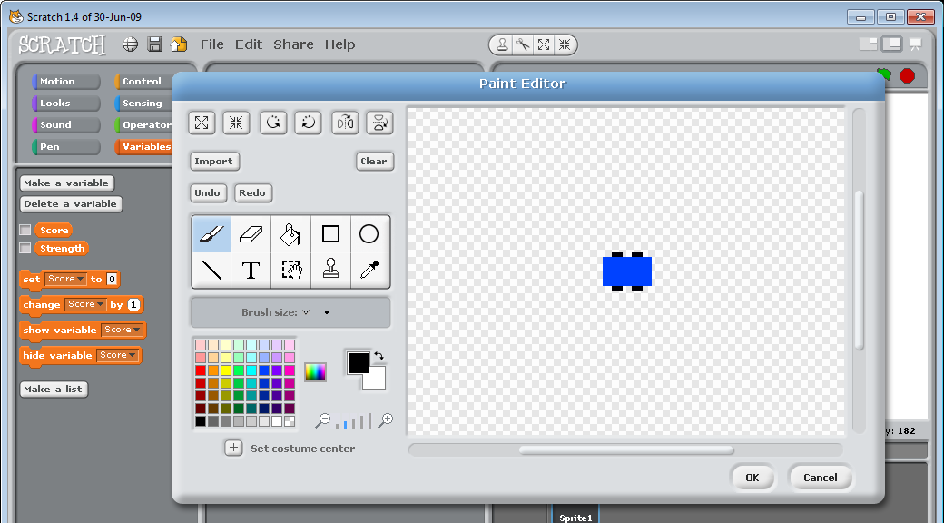
- Lets start off by creating our racing car
- Select sprite 1 and click costumes and then click edit on costume1
- Click clear and then draw a top view of a car
- Once you’ve finished click ok and then delete costume 2

Task 2
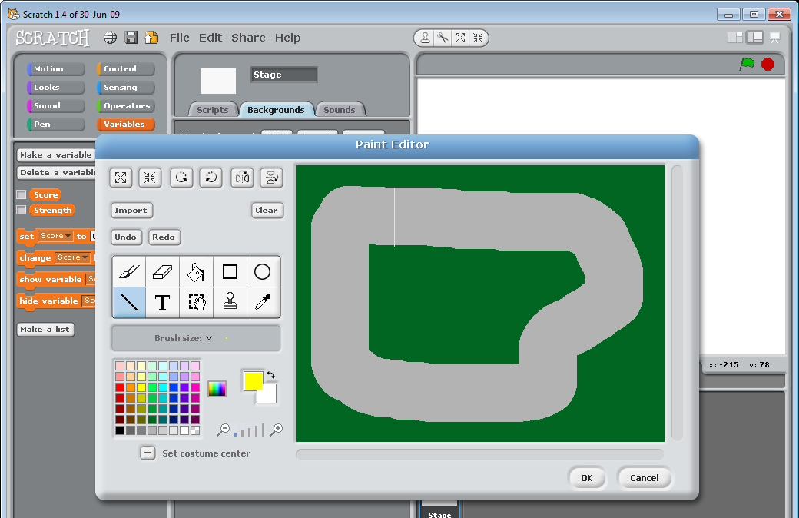
- Now lets create a racing track for our car to drive around
- Click stage and then on the backgrounds tab click edit for background1
- Using the paintbrush tool select the largest brush size and then draw a grey road going around the screen
- Using the bucket tool colour in the surrounding area green
- Using the line tool draw a yellow line across the track to create a finish line. (don’t forget to make sure you’re using the smallest brush size
- Now click ok to return you to the previous screen

Task 3
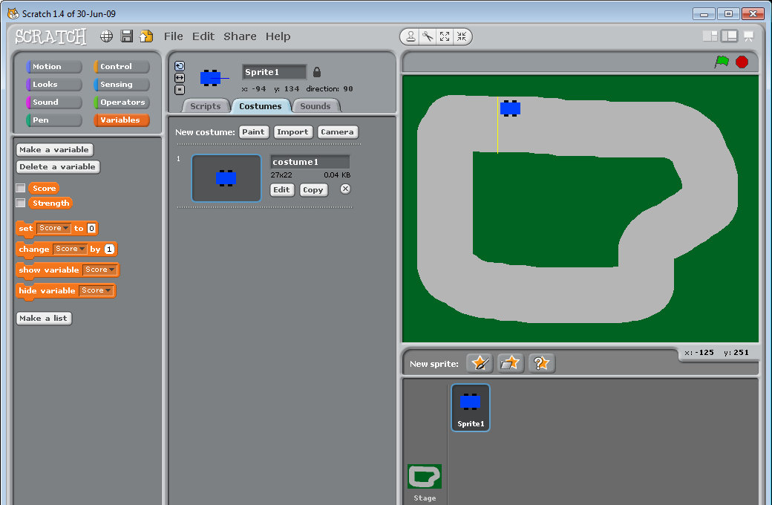
- Now select sprite1 and place your car at the starting place on the screen(just after the yellow starting line

Task 4
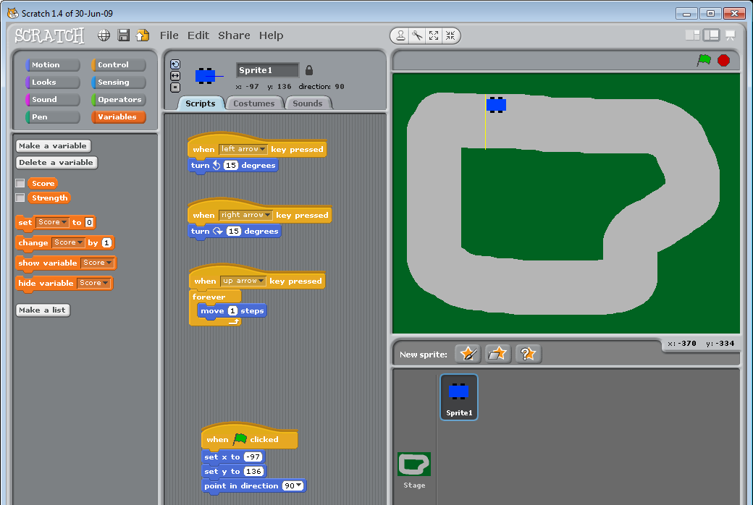
- Now select scripts for sprite 1
- Add the following:
  - When left arrow key pressed turn anti-clockwise 15 degrees
  - When right arrow key pressed turn clockwise 15 degrees
  - When up arrow key pressed forever move 1 steps
  - When green flag clicked set x to (current position of you car), set y to (current position of your car), point in direction 90
- Have a quick play now by clicking the green flag

Task 5
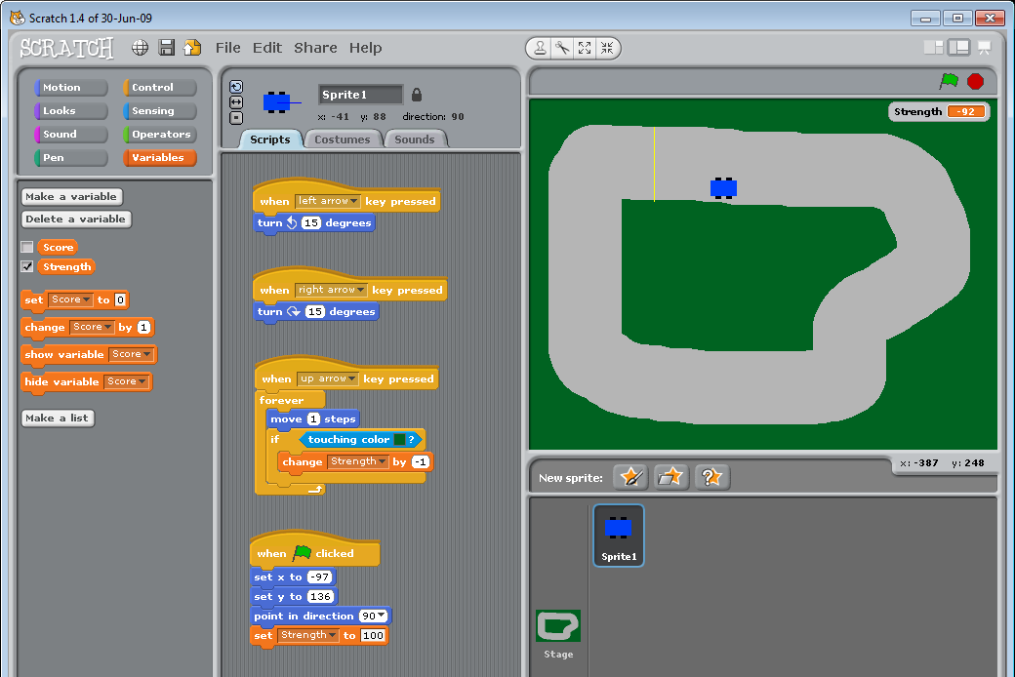
- Now lets add a script so that if car goes on the green grass you lose points
- Add a variable called strength
- Then add a script setting the score to 100 when the green flag is clicked
- Now add a script in the forever loop that if touching color green change strength by -1
- Have a quick play now by clicking the green flag

Task 6
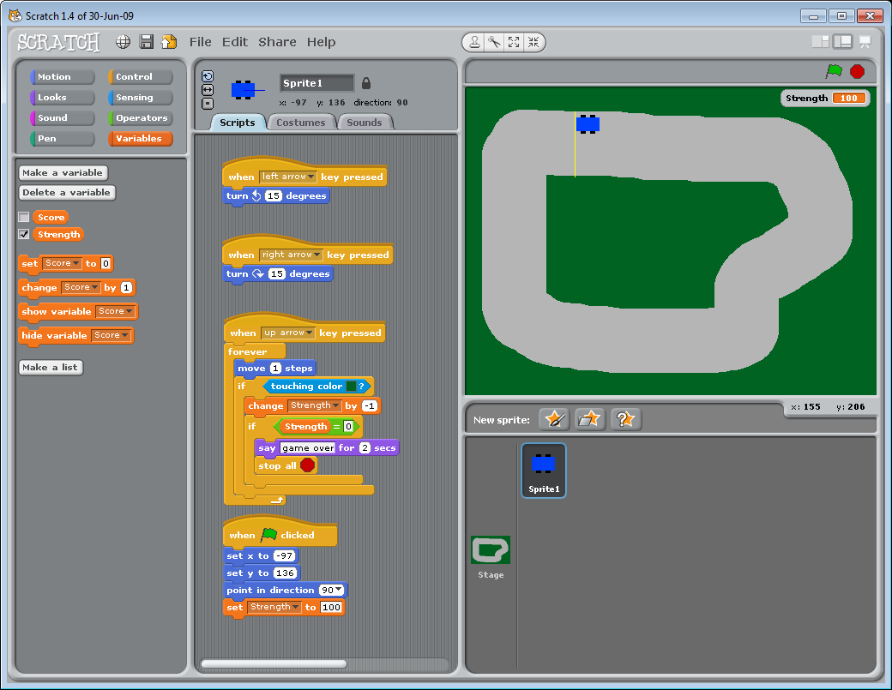
- Now lets add a script so that if the strength gets to 0 then the game is over
- Underneath the ‘change strength by -1 script add the following if statement :
  - If strength=0 say gameover for 2 seconds, and stop all

Task 7
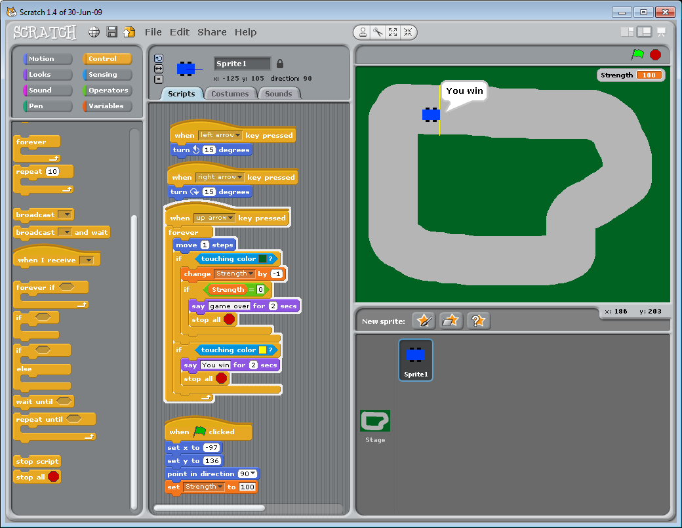
- Now lets add a script so that if the car goes over the yellow line the games stops and the playyer wins
- Underneath the if touching colour green statement has finished add the following if statement:
  - If touching color yellow, Say you win for 2 secs and top all

Project 4: Helicopter
For this objective we will learn about:
- Forever loops
- IF (Conditional) statements

Task 1
- To start off with we need to download some graphics to use in our project
- If you have printed this sheet you can download them from http://www.eastonhome.co.uk/Scratch/helicopter/index.htm
- Don’t forget to save the file in your ICT folder inside the folder called lesson 3.
- Once downloaded the file you will need to extract the files
- If you are stuck then please ask your teacher for help

Task 2
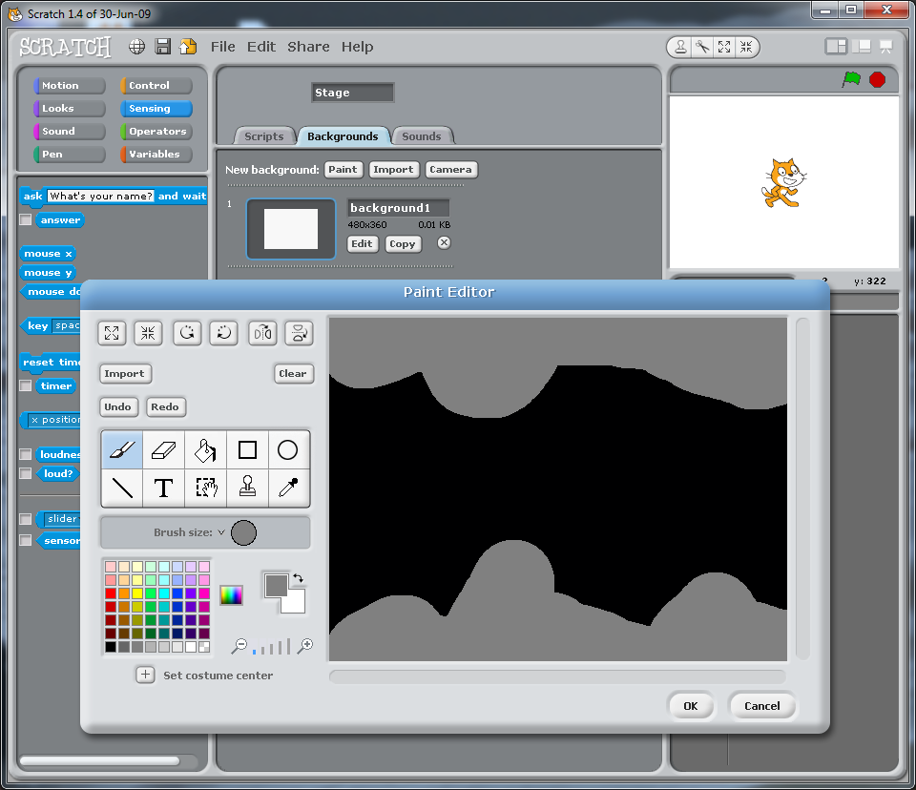
- Let’s start off by creating the background
- Click Stage > Backgrounds > edit
- Use the Fill tool and set the background to black (this will be the dark background to our helicopter cave)
- Now let’s use the paintbrush tool to create the top and bottom of the cave. Set the brush to the largest size and colour grey, draw the top and bottom of the cave
- Click OK on the paint editor to return you to the main scratch window
Task 3
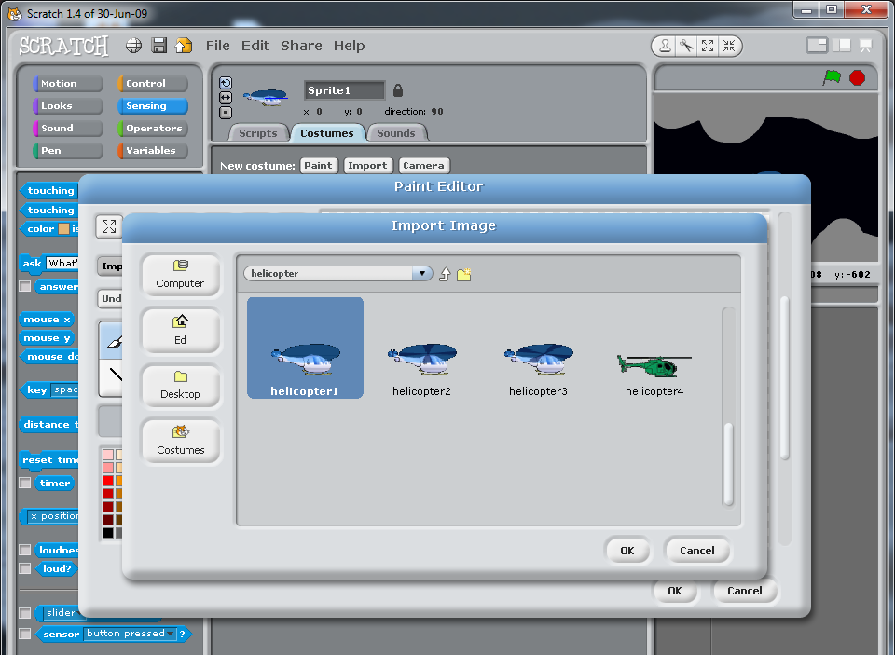
- Now Let’s change the default cat sprite to a helicopter
- Click Sprite 1 and delete costume 2
- Click edit on costume 1 and then click clear
- Click import and navigate to your ICT folder lesson 3
- Select helicopter1 and click OK to return you to the paint editor and then OK again to return you to the scratch costumes menu
- Rename Costume1 to Helicopter1

Task 4
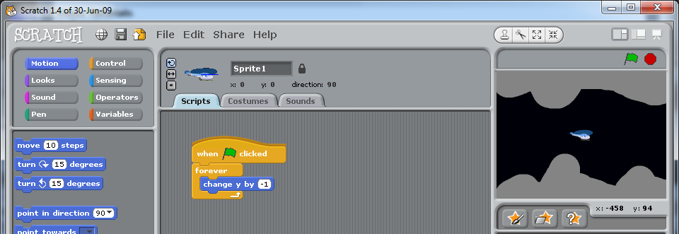
- Now let’s add some code so that our helicopter can move
- We’ll start by clicking script for sprite 1 so that we can add some code.
- We’ll set the helicopter is left on its own it slowly goes down to the ground
  - When the green flag is clicked forever change y by -1
- Test your code

Task 5
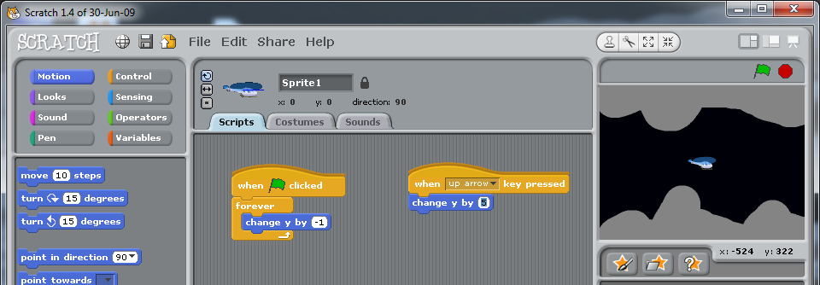
- Now we’ll add some code to allow the helicopter to fly up
  - When up arrow key is pressed change Y by 5
- Test your code

Task 6
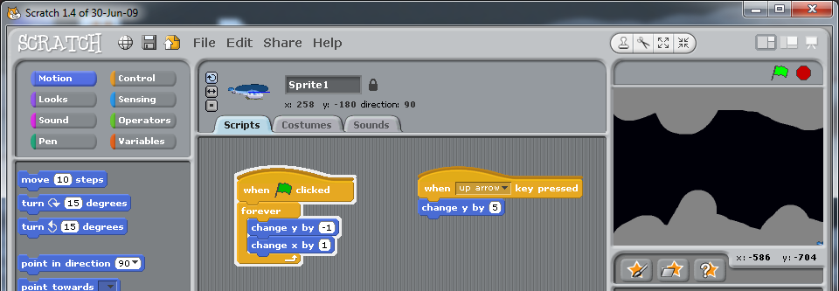
- Now we’ll add some code to allow the helicopter to fly forward automatically when the game begins
  - Change X by 1
- Test your code

Task 7
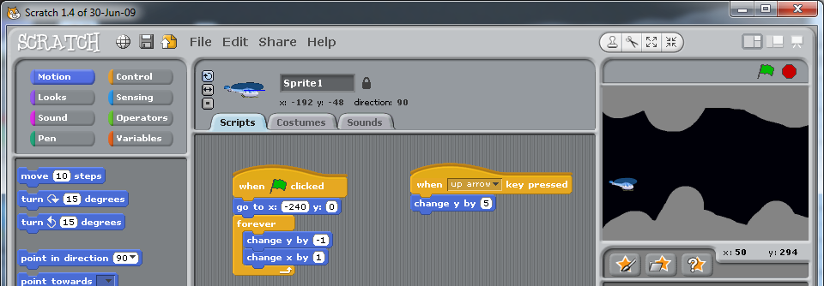
- Each time we test the code we need to drag the helicopter back to the start point. Let’s add some code so that the computer does this automatically when the game starts.
  - Go to x: -240 y: 0
- Test your code. Does it start on the left hand side automatically when the green flag is pressed?

Task 8
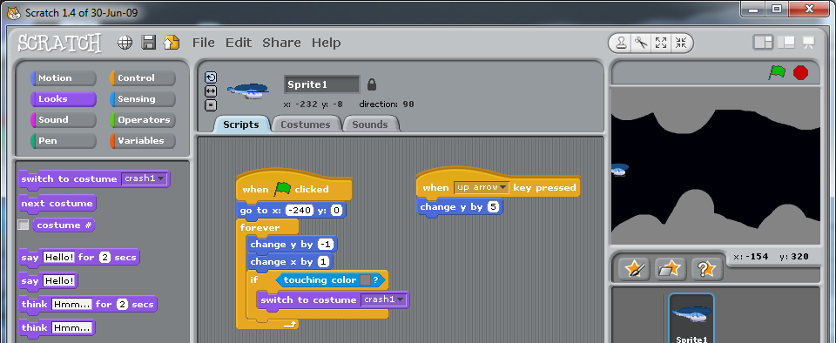
- Now let’s set some code so that if the helicopter touches the rocks at the top or bottom of the cave then it will burst into flames.
- Click on Costumes > import
- Select crash05 and click OK
- Click Scripts
- Let’s add some code so that the costume changes when the helicopter touches rock.
  - If touching colour grey then switch to costume crash1
- Add this code to the bottom of your forever loop (after the X & Y are changed)
- Test your code, does it work?

Task 9
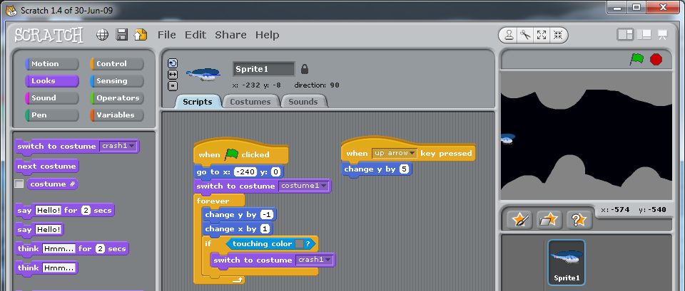
- Let’s also add some code so that the helicopter isn’t already exploded when it starts the game
  - Switch to costume: helicopter1
- Test your code, does it work?

Task 10
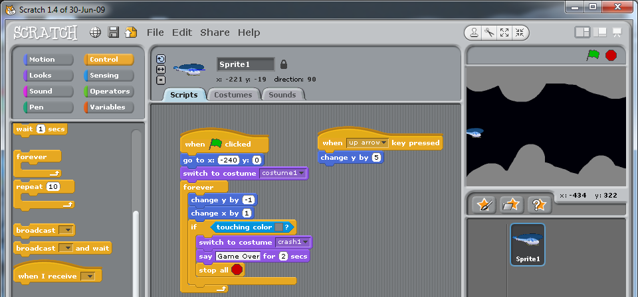
- We also need to add some code so that when the Helicopter blows up the game ends.
- Underneath the code that switches the costume to crash 1 add:
  - Say game over for 2 seconds and stop all
- Test your code, does it work?

Task 11
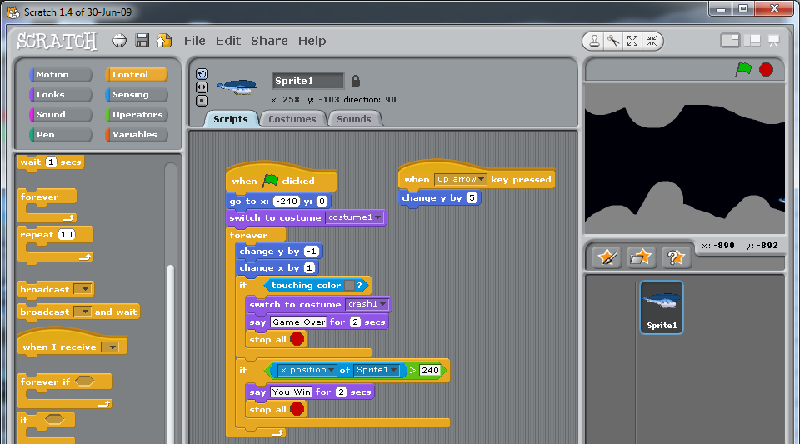
- Now let’s add some code so that when the helicopter gets to the other end of the screen, the player wins.
  - If x position of sprite1 > 240 then say you win for 2 seconds and stop all

Task 12 (Extension 1): Helicopter animation
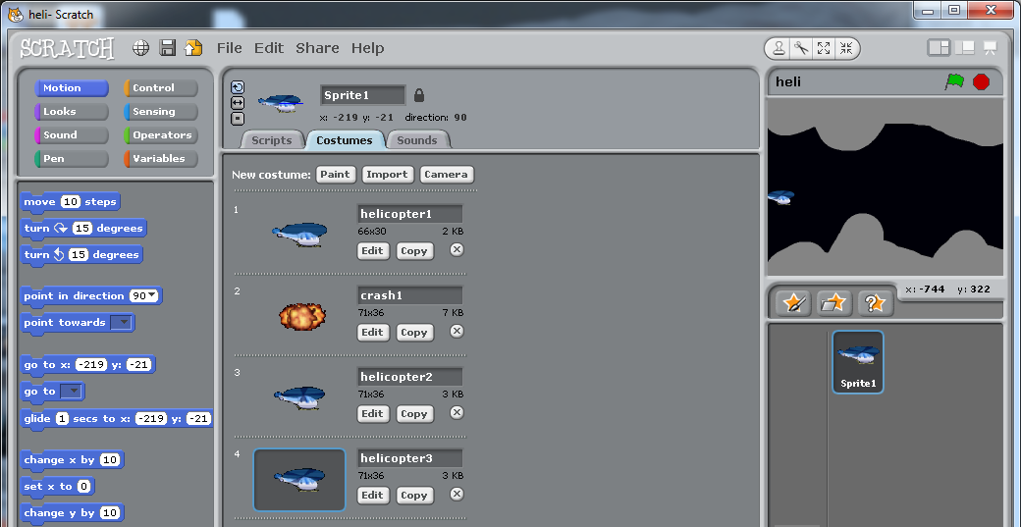
- Now let’s set it so that the Helicopter flying looks a little more realistic. Let’s set it so the costume changes whilst it is flying.
- Click Costumes
- Click Import and select Helicopter 2 and click OK
- Click Import and select Helicopter 3 and click OK
- Back on your scripts
- Add the following code:
- 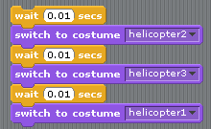
- Place your code just above the first if statement like this:
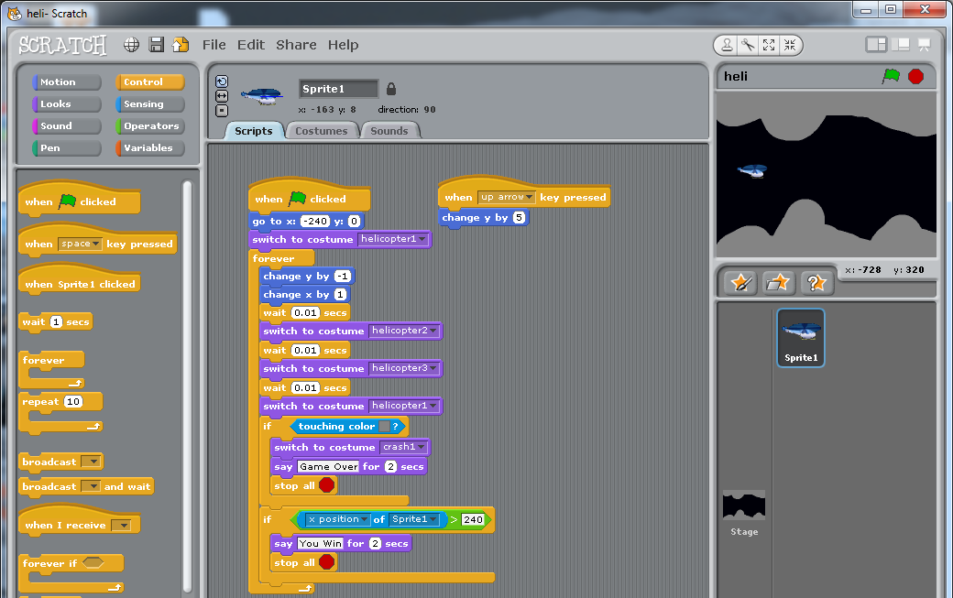

Task 13 (Extension 2): Explosion animation
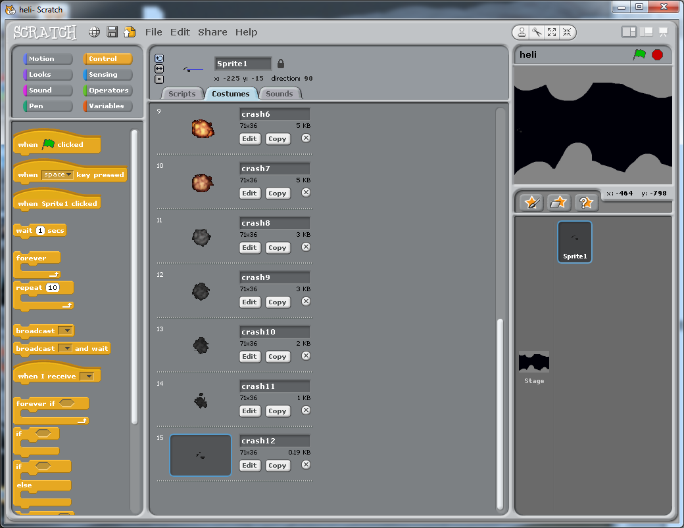
- Now let’s set it so that the Helicopter explosion looks a little more realistic. Let’s set it so the costume changes when it crashes.
- Click Costumes
- Delete the existing crash costume
- Click Import and select Crash 1 and click OK
- Repeat the import process so that you have all 12 imported
- Back on your scripts
- Add the following code:
- 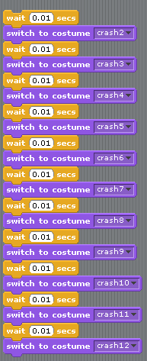

- Place your code just below where you already have switch to costume crash 2
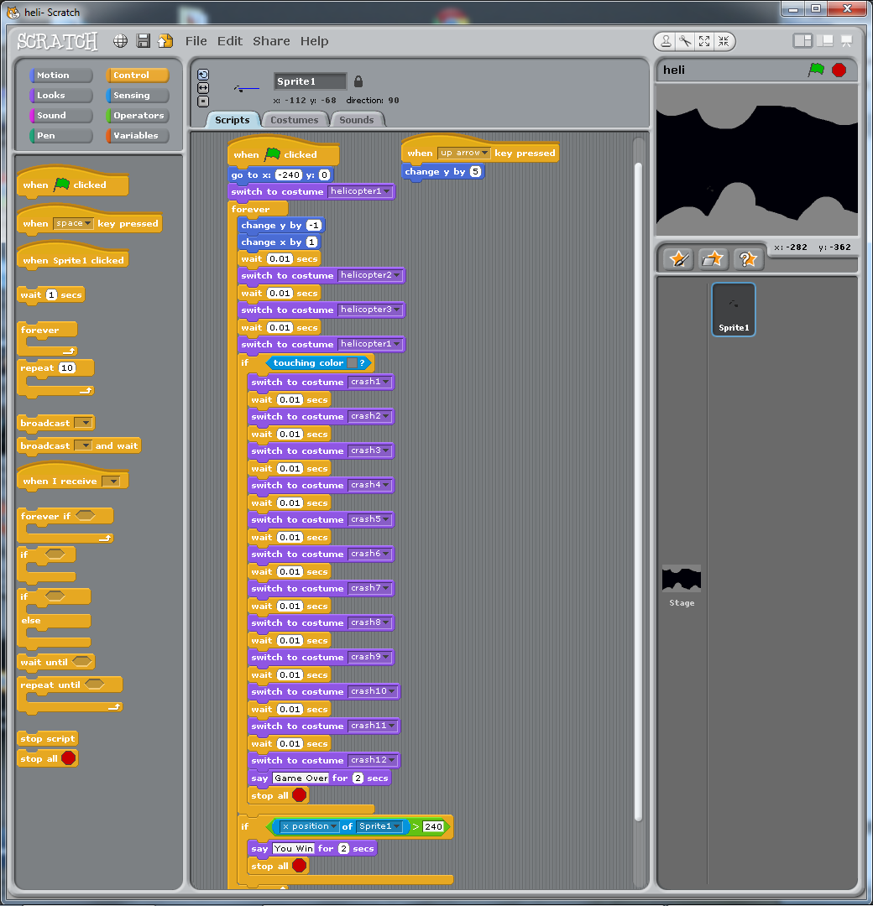

Project 5: Tanks
For this objective we will learn about:
- Forever loops
- IF (Conditional) statements

Task 1
- To start off with we need to download some graphics to use in our project
- If you have printed this sheet you can download them from http://www.eastonhome.co.uk/Scratch/tank/index.htm
- Don’t forget to save the file in your ICT folder inside the folder called lesson 4.
- Once downloaded the file you will need to extract the files
- If you are stuck then please ask your teacher for help

Task 2
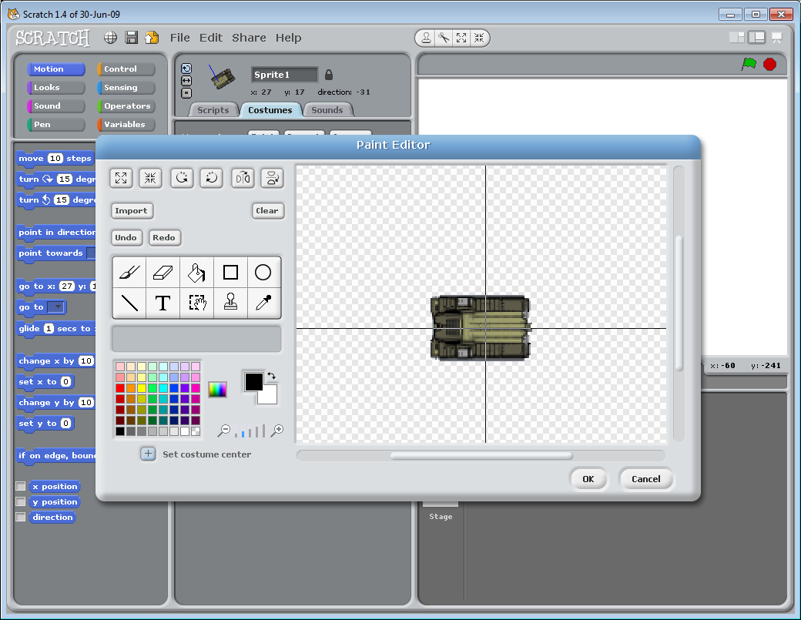
- Let’s start off by creating adding the tank base. Click 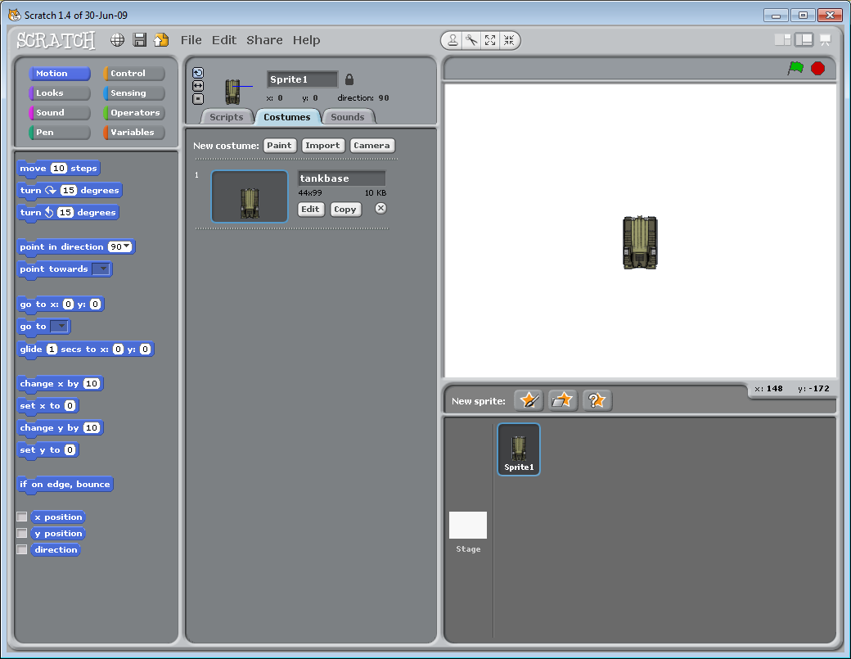 and navigate to where you’ve got the pictures saved. Select TankBase and click ok.
- Now let’s click edit and then click 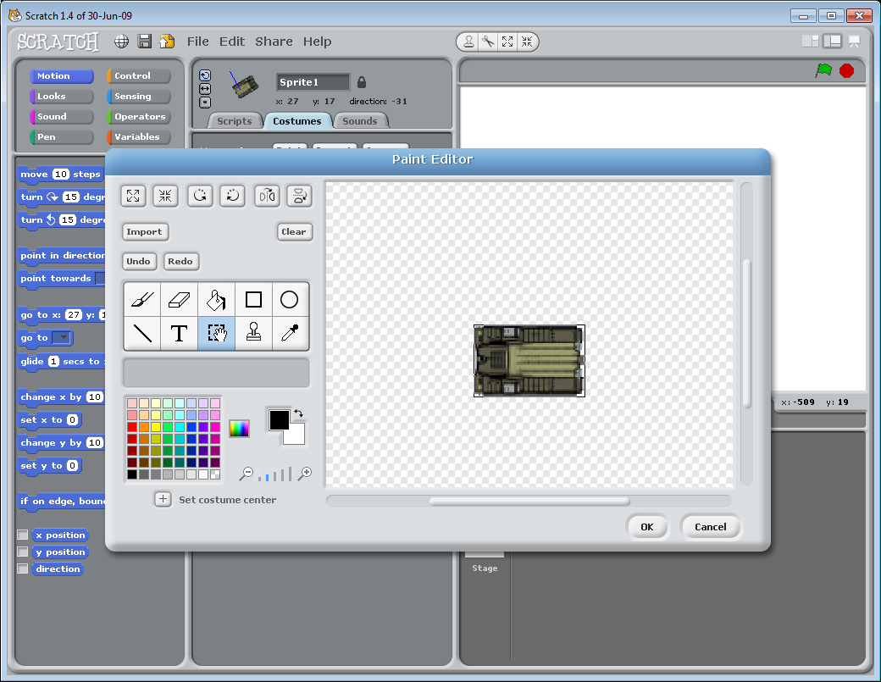 3 times to rotate round the tank base
- Now lets set the costume center. Click and then click in the middle of the tank base.

Task 3
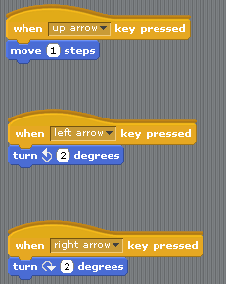
- Add some scripts so that:
  - When up arrow key is pressed the TankBase goes 1 step forward.
  - When the left arrow key is pressed the TankBase goes 2 degrees to the left.
  - When the right arrow key is pressed the TankBase goes 2 degrees to the right.

Task 4
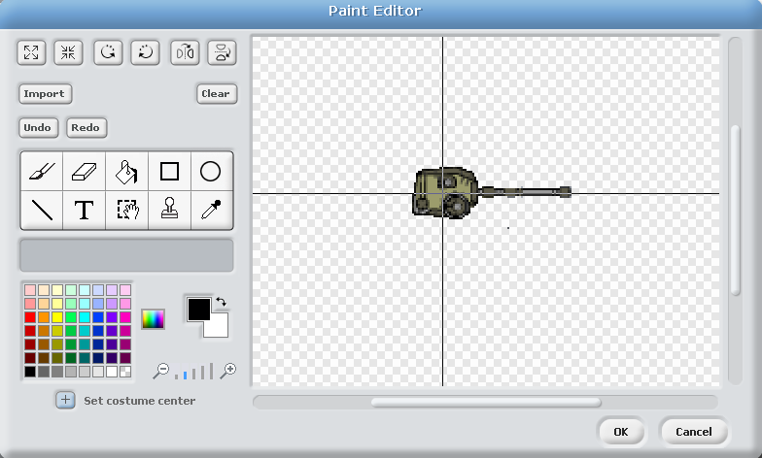
- Now we’re going to add a 2nd sprite. Click and navigate to where you’ve got the pictures saved. Select turret1 adnc click OK
- Now let’s click edit and then click 3 times to rotate round the tank base
- Now lets set the costume center. Click and then click in the middle of the tank base.

Task 5
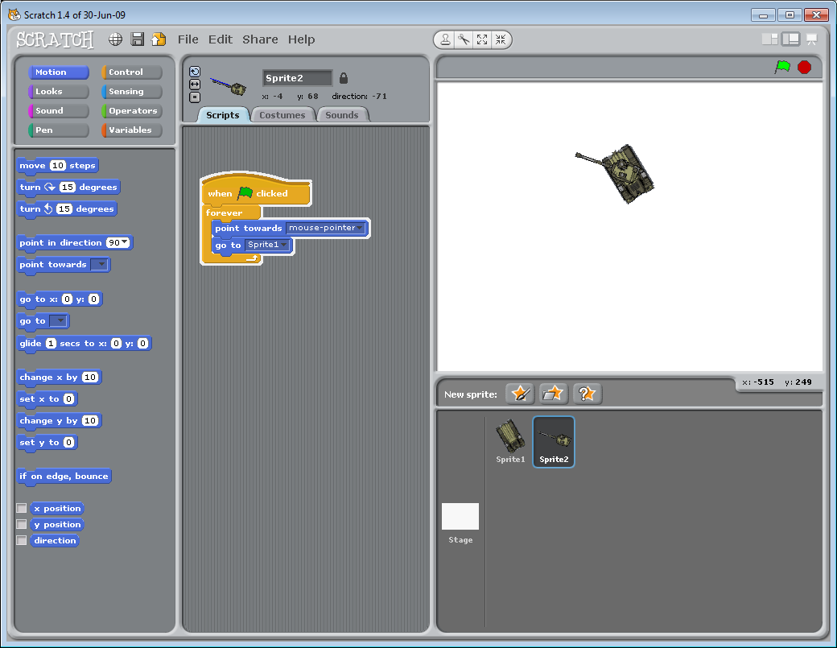
- Let’s add a script for the turret to follow the mouse and to sit on top of the TankBase
  - When green flag is clicked forever point towards the mouse pointer.

Task 6
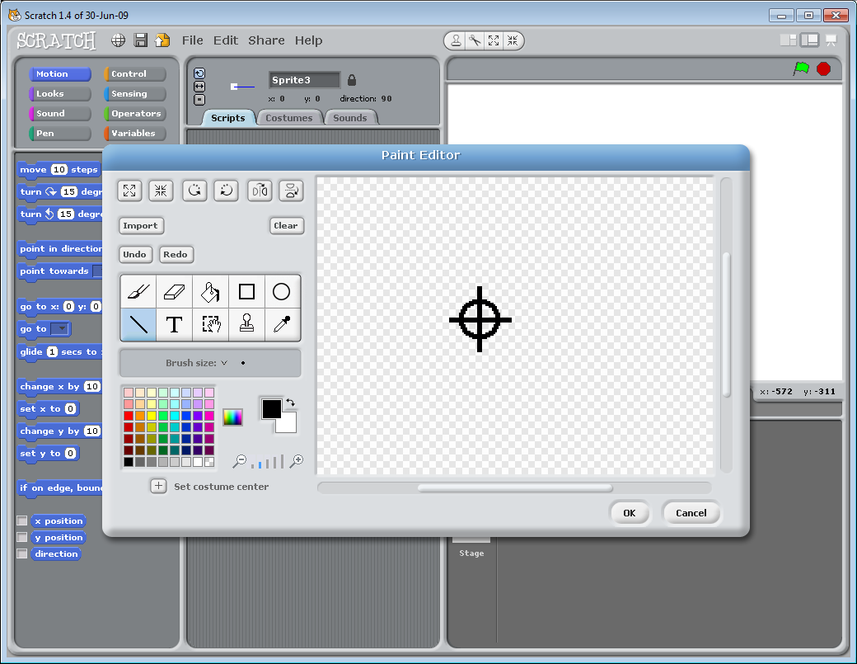
- Let’s create a target
- Click and draw a target

Task 6
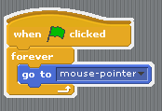
- Let’s add a script for the target sprite (sprite3) so that the target moves around with the mouse.

Task 7
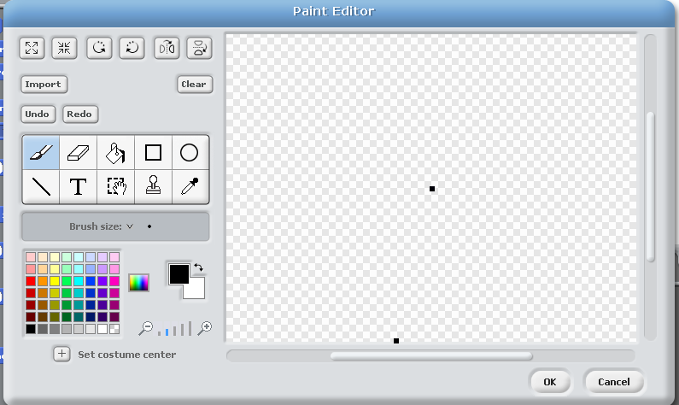
- Let’s create a missile
- Click and draw a missile (just a black dot)

Task 7
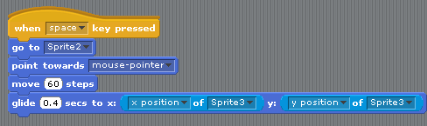
- Now let’s add a script for this missile (sprite4) so that when the space bar is pressed it fires from the turret to the target.

Task 8
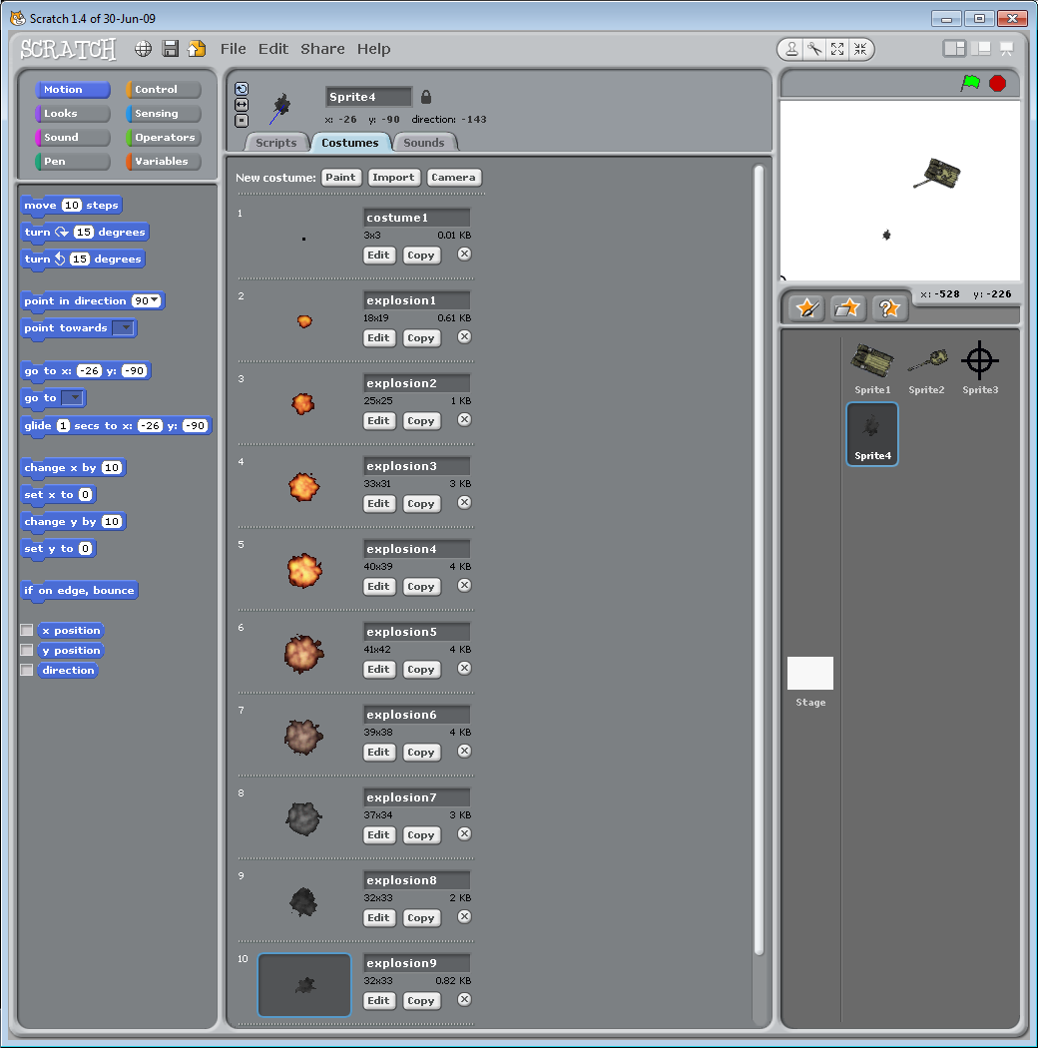
- Now let’s add more costumes for the missile so that we can get it to explode
- For sprite4 click costumes and then click import. You’ll need to import:
  - Explosion1
  - Explosion2
  - Explosion3
  - Explosion4
  - Explosion5
  - Explosion6
  - Explosion7
  - Explosion8
  - Explosion9

Task 9
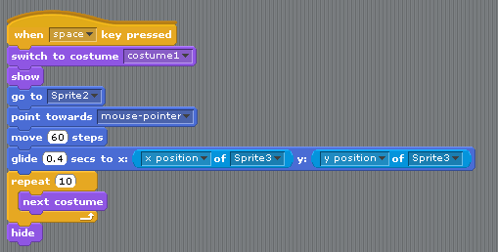
- Now let’s add some more to our script for sprite4.
- Edit the script so that it switches to costume1 and shows itself
- Finally edit the script so that once it finished gliding it changes costume 10 times and then hides itself.

Extension activity
- Add a background (either design your own or use the one that is in the resource area.
- Add an explosion sound to the missile
- Add another sprite that travels across the screen. Set this sprite to explode when the missile sprite touches it.

Now Save this project in your ICT folder inside your folder called Lesson 4 as TankGame

Progress check - End of unit
- I understand.
- I kind of understand.
- I don’t understand.

Objective 1: Introduction to the Scratch Programming environment
I can…
Create new code
Edit existing code
Save a scratch file
Open a scratch file

Objective 2: Loops
I can…
Create a Repeat Loop
Create a Forever Loop

Objective 3 – Conditional
I can…
Create an IF (conditional) statement
Create an IF ELSE (conditional) statement
Create a nested IF (conditional) statement

Objective 4 – Variables
I can…
Create a variable
Assign a value to a variable
Change a value in a variable

Objective 5 – Comparison operators
I can…
Use a greater than
Use a less than
Use an equals

