SCRATCH – Getting started

Task 1
Go to https://scratch.mit.edu/join

Task 2
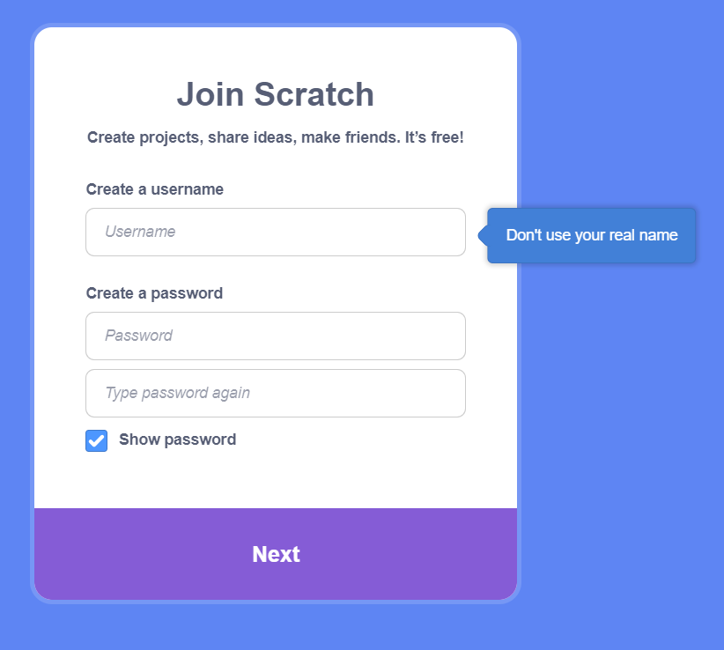

Task 3
When prompted for your email address you should use your school email address
firstname.lastname@thetauntonacademy.com
For example: jason.smith@thetauntonacademy.com

Task 4 - You will be able to see any scratch projects you have created by clicking your username and selecting ‘My Stuff’
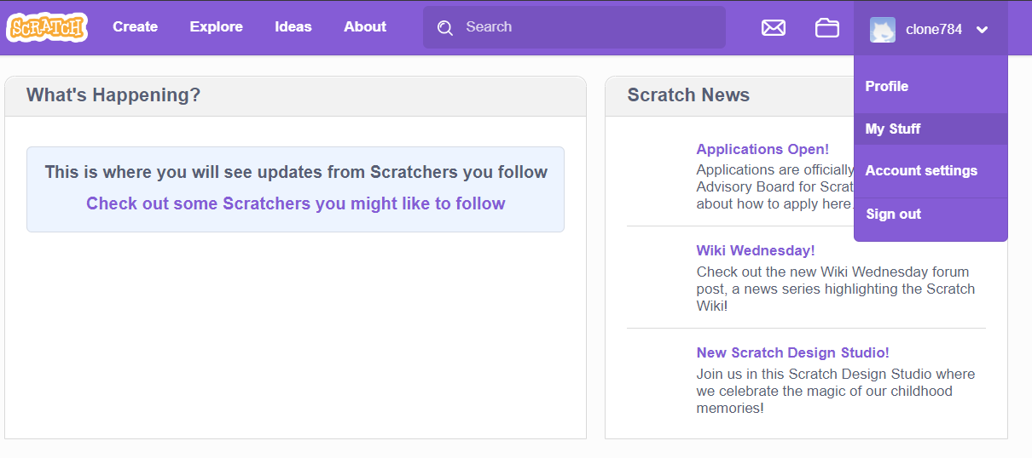

Task 5 - To create a new scratch project click Create
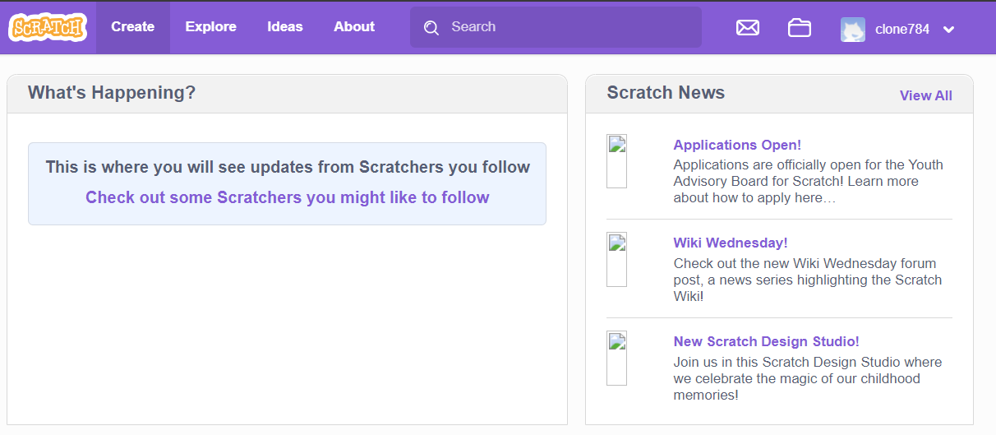
Task 6 – Create your project!
