SCRATCH – Helicopter (Beginner)

Task 1: download files
Download and extract all the media files (15 image files)
Task 2: Create the backdrop
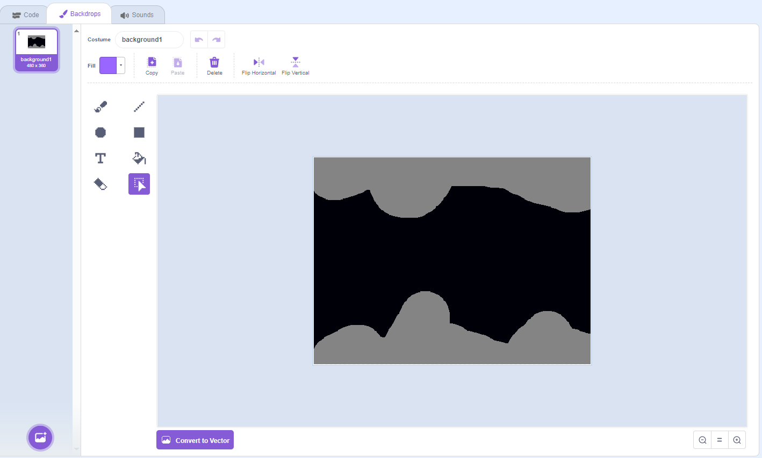
Task 3: Costume for sprite 1
Import all the costumes for sprite 1
Make sure the images are in the correct numbered order
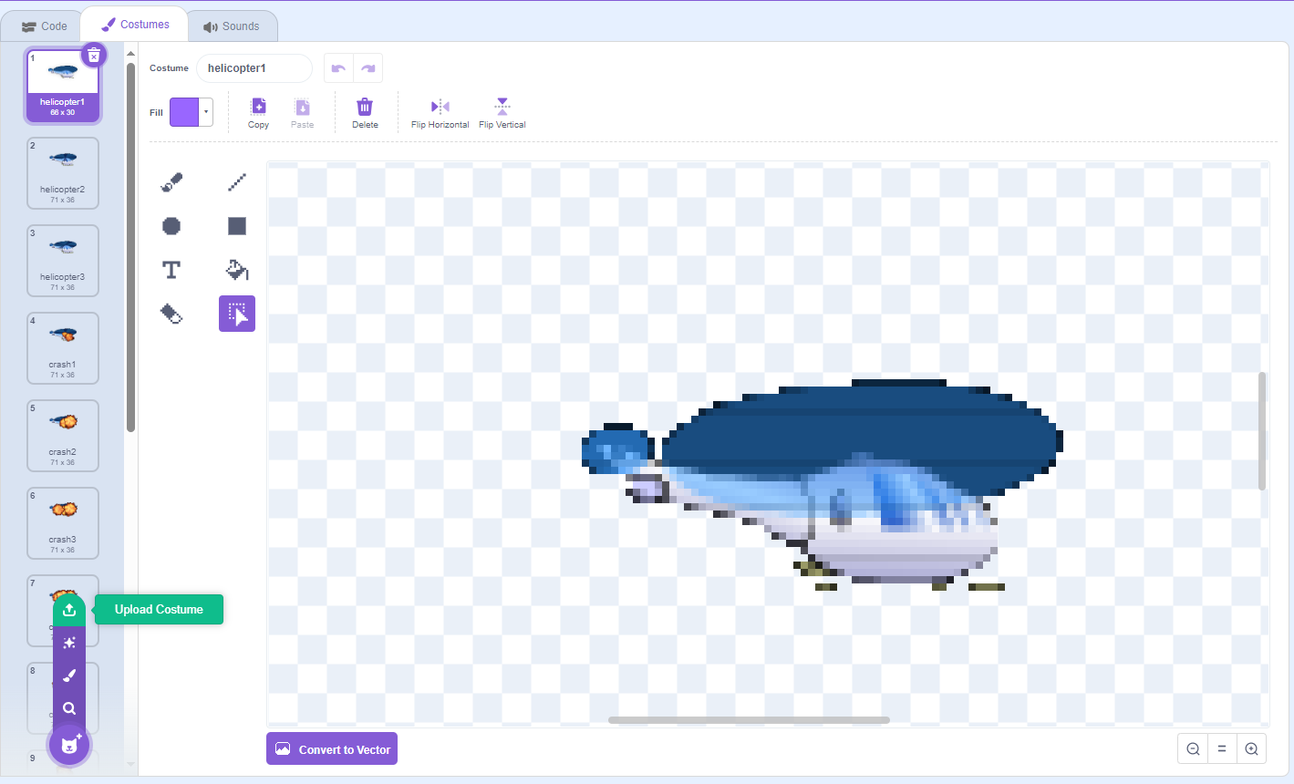
Task 3: Code for sprite 1
