SCRATCH – Tank (Beginner)

Task 1: download images
Start off by downloading the
- Tankbase
- Tank Turret
- Tank explosions (x9 images)

Task 2: Sprite 1 costume
*make sure the centre of the tank base is on the crosshair
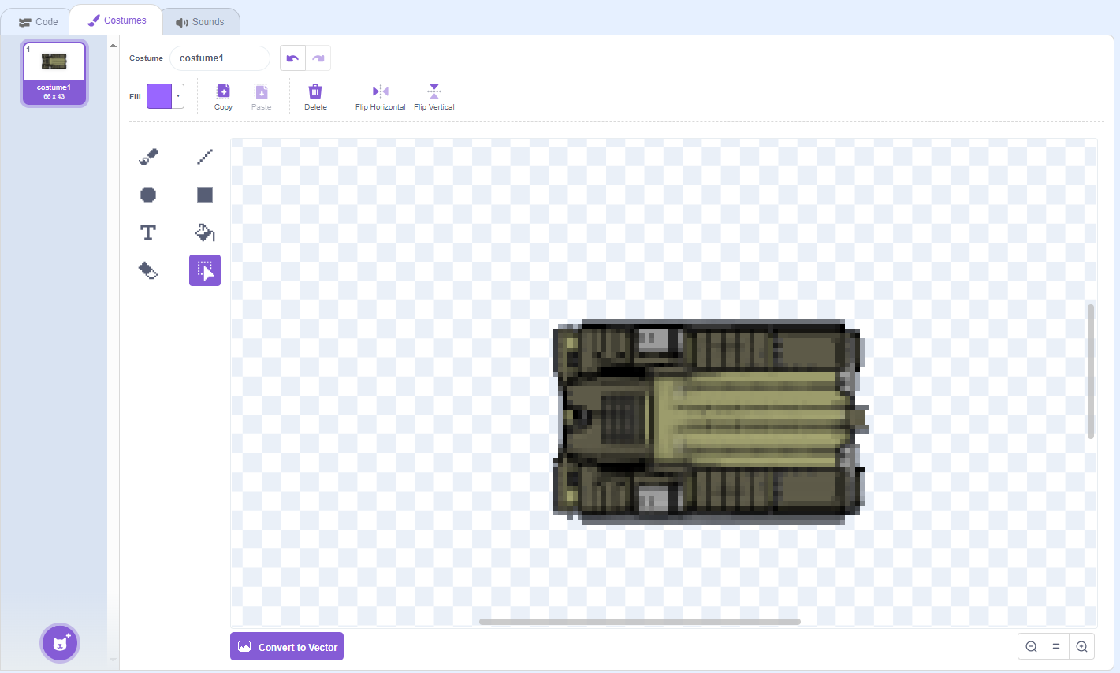

Task 3: Sprite 1 code
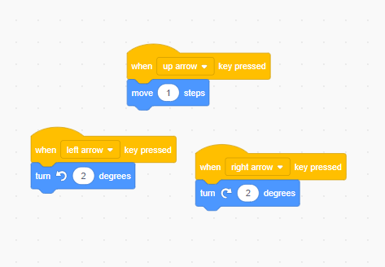
Task 4: Sprite 2 costume
*make sure the centre of the tank turret is on the crosshair
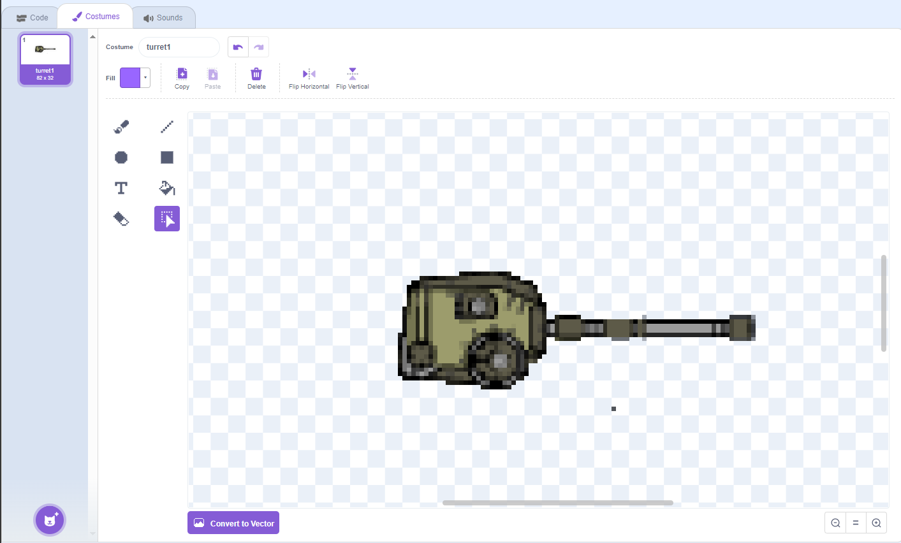

Task 5: Sprite 2 code
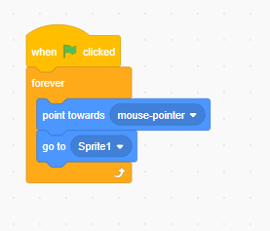

Task 6: Sprite 3 code
You’ll need to draw this one yourself!
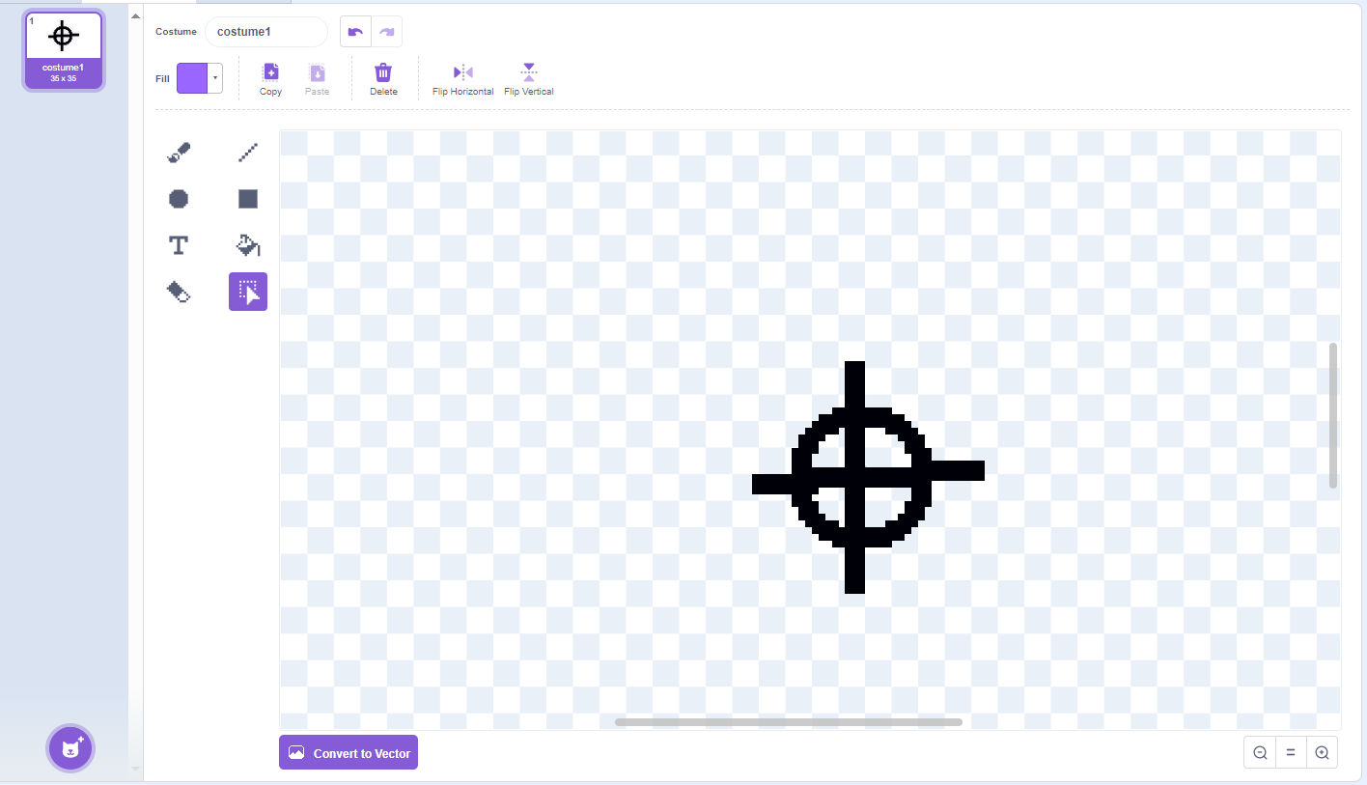

Task 7: Sprite 3 code
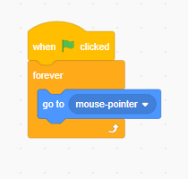

Task 8: Sprite 4 code
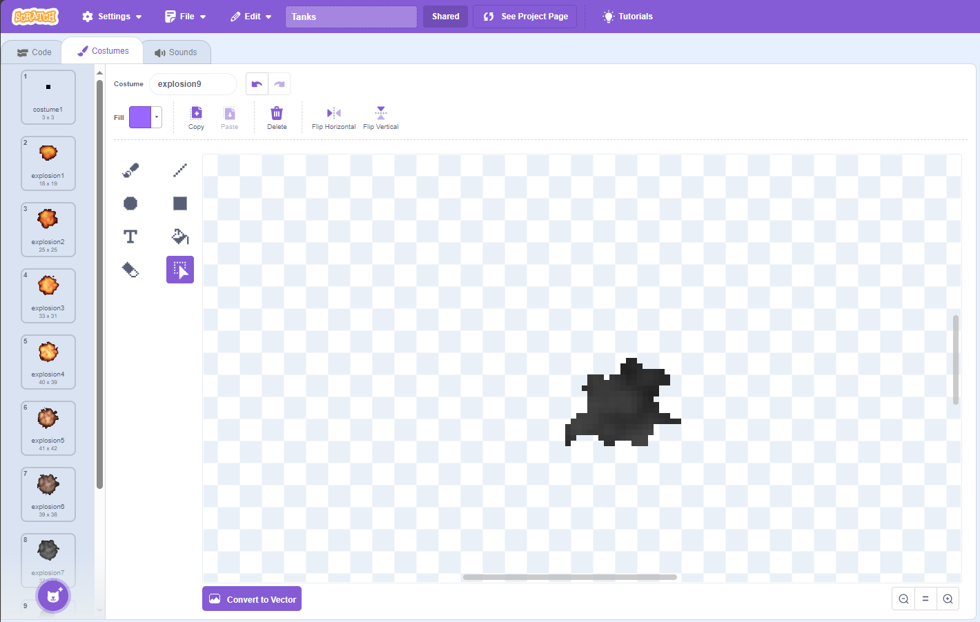

Task 9: Sprite 4 code
