SCRATCH – Walking (Beginner)

Task 1: Copy the sprite 1:
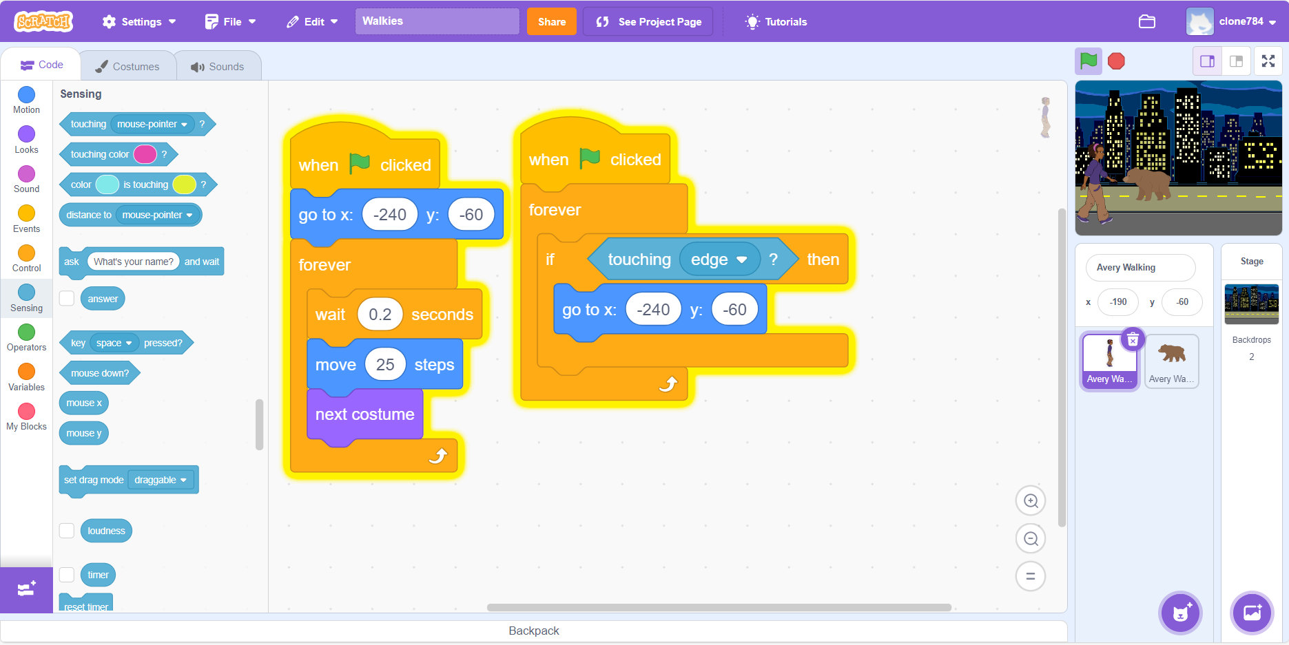

Task 2: Copy the sprite 2
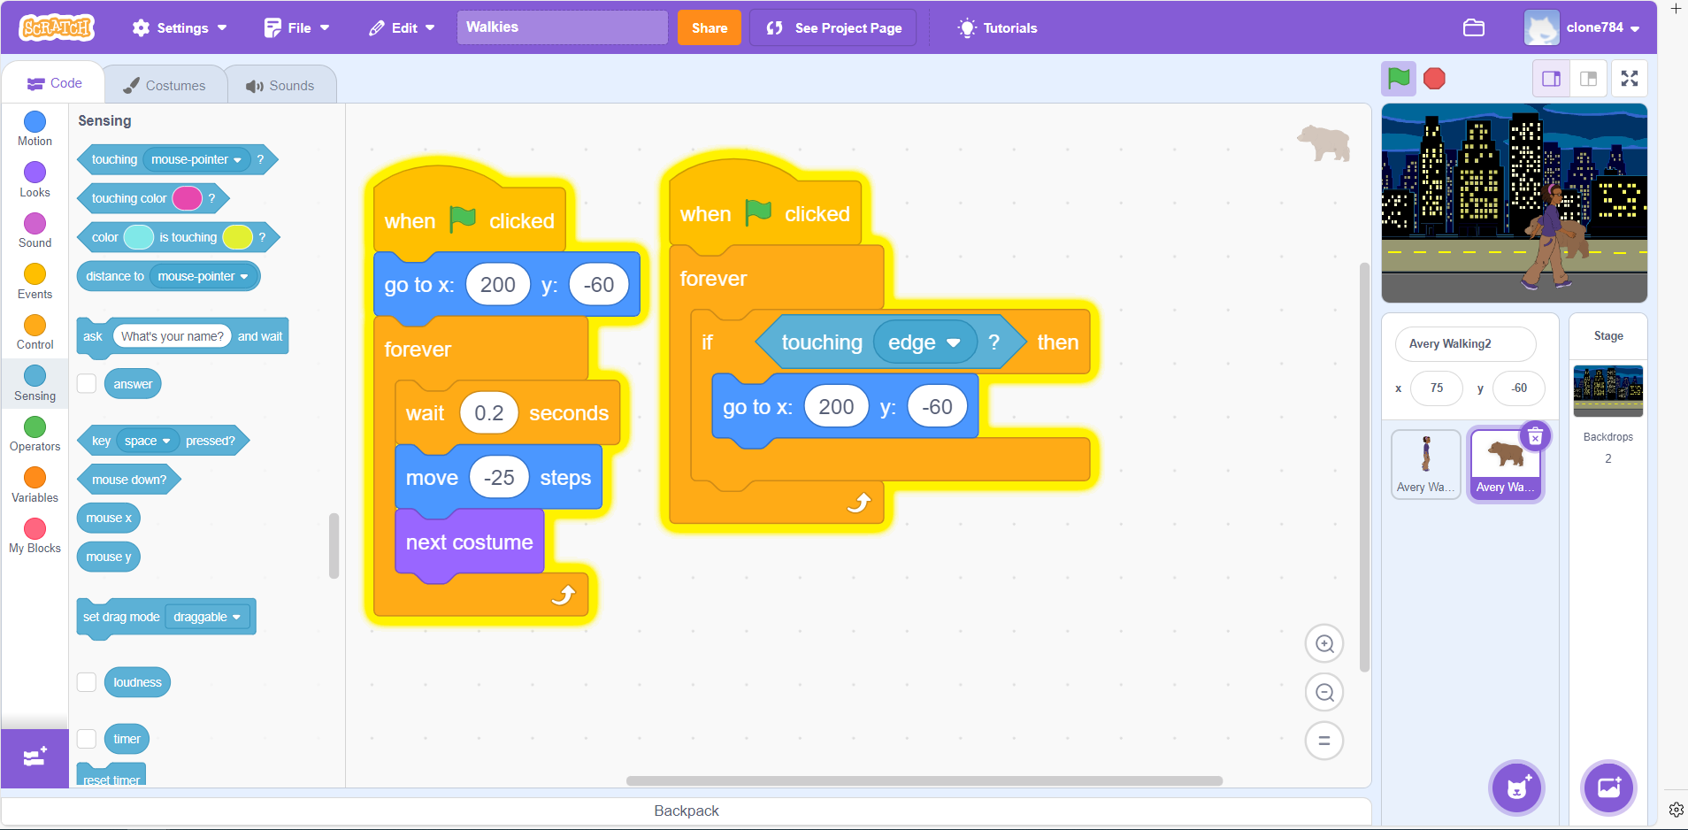

Task 3: Don’t forget to add in a backdrop!

Task 4: Can you add in a new sprite that moves across the screen? Use the code from sprite 1 or 2 to help you.

