 | Event 1 | Event 2 | Event 3 | Event 4 | Event 5
 |  | 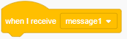 | 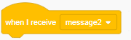 |  | 
Looks
- Show
- Hide
- Say
-Costume
Movement
- Goto
- Glide
Backdrop
Sound
 |  |  |  |  | 
 | Event 6 | Event 7 | Event 8 | Event 9 | Event 10
 | 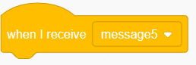 | 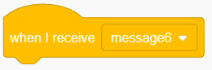 | 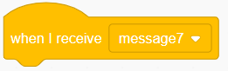 | 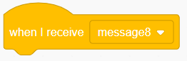 | 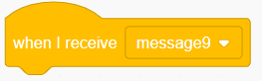
Looks
- Show
- Hide
- Say
-Costume
Movement
- Goto
- Glide
Backdrop
Sound
 |  |  |  |  | 

Planning:
Use this worksheet to help you plan your cartoon.
SCRATCH Tools
You may wish to use the following SCRATCH tools to complete your cartoon.
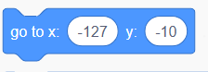 |  | 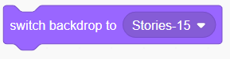 | 
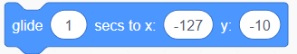 | 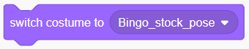 |  | 
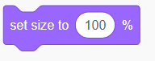 | 