A Style of your own
Microsoft Word has many existing styles, but can you create your own styles?
On the Home tab in the styles section, expand it to see a menu with more options. At bottom is the option to create a New Style (Left button).
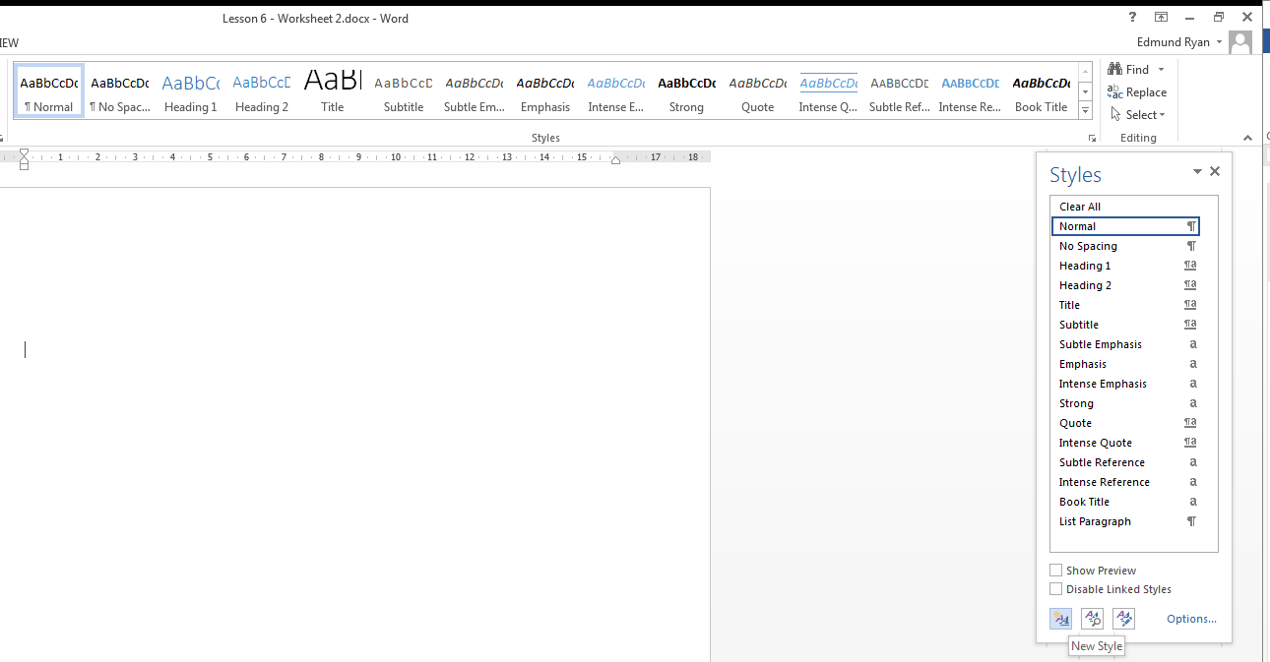
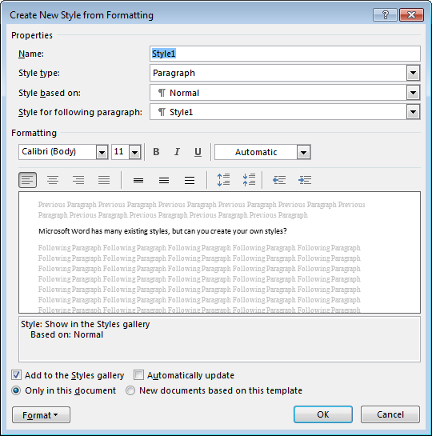

- Design and create 3 styles. Make use of Character and Paragraph style options.

