Storymaker Python Challenge
Student workbook and teacher reference
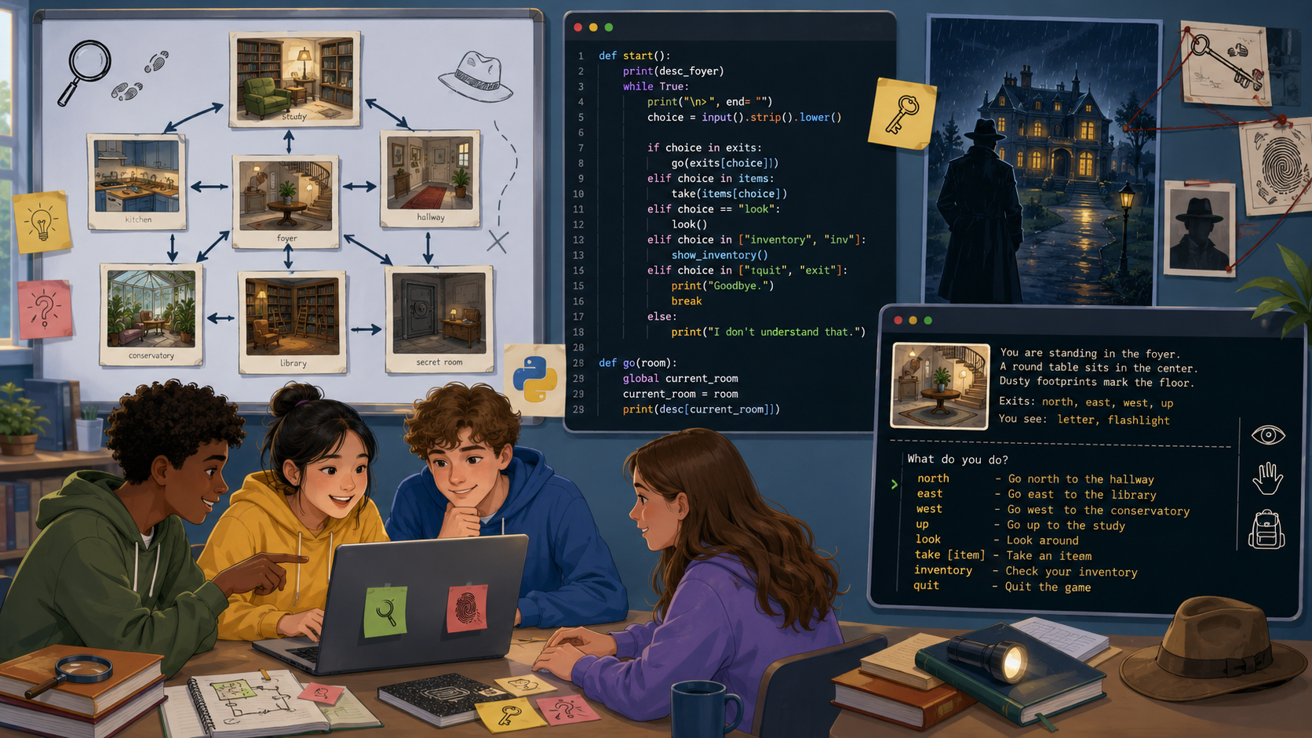
Name: ____________________________________ Class: __________________ Date: _______________
Your mission: Adapt a Python text-adventure template so it becomes a complete mystery story with meaningful choices, clues, testing evidence, and working navigation.

Starter file: Storymaker.py - Created by Mr E Ryan, 14/05/2026

1. Lesson overview
Use this page to understand what you are aiming to build.
Learning objectives
- Explain how functions are used to represent rooms and actions.
- Use input, output, strings, Booleans, while loops, and if / elif / else statements.
- Adapt existing code safely without breaking the room navigation.
- Test a text adventure and record evidence of fixes.
Key vocabulary
Keyword | Meaning | Example from the challenge
function | A named block of code that can be called. | hallway(), door1(), peter()
while loop | Repeats code while a condition is True. | while flag == True:
if / elif / else | Checks choices and chooses a path. | if choice.lower() == "d1":
Boolean | A True or False value. | flag = True
string | Text stored or printed by the program. | "You are in Room 1"

2. Starter: play, predict, discuss
Before editing, predict how the program works.
First run: Run the starter program once. Do not edit anything yet. Try moving to at least two rooms and then returning to a hub.

What type of game is this program trying to create?
____________________________________________________________________________________
Which function runs first when the program starts?
____________________________________________________________________________________
What input would take the player upstairs?
____________________________________________________________________________________
What happens when an invalid choice is typed?
____________________________________________________________________________________
Which part of the introduction creates the mystery atmosphere?
____________________________________________________________________________________

3. Code detective: function map
Each function is a location or action. Complete the purpose column.
Function | Type | What it does | Calls / returns to
start() | start |  | hallway()
hallway() | hub |  | door1-4, staircase("u")
landing() | hub |  | door5-8, staircase("d")
door1() | room | Office | hallway()
door2() | room | Kitchen | hallway()
door3() | room | Living room | hallway()
door4() | room | Games room | hallway()
door5() | room | Bedroom | landing()
door6() | room | Master bedroom | peter(), landing()
door7() | room | Child's bedroom | landing()
door8() | room | Bathroom | landing()
peter() | dialogue |  | stays in dialogue until leave

4. Trace a route through the story
A trace table helps you understand what the code is doing step by step.
Route to trace: Start the game, type d6, then w, then s, then 1, then l. Record which function is running at each step.

Step | User input | Function running | What the program prints / does | Next function or state
1
2
3
4
5
6
7
Challenge: What would happen if the player typed W instead of w? Explain why.
____________________________________________________________________________________
____________________________________________________________________________________

5. Python pattern: while loops and flags
The menu repeats because a Boolean flag controls a loop.
flag = True
while flag == True:
choice = input("Where would you like to go? ")
if choice.lower() == "d":
flag = False
hallway()
else:
print("Try again.")
Answer the questions
What value does flag have at the start of the loop?
____________________________________________________________________________________
What line stops the loop?
____________________________________________________________________________________
Why would the program feel broken if flag never changed?
____________________________________________________________________________________
Rewrite while flag == True in a shorter Python style.
____________________________________________________________________________________

6. Python pattern: if / elif / else
Menus work by comparing the player choice with expected letters.
choice = input("Choose: (F)ireplace or (D)oor ")
if choice.lower() == "f":
print("At the fireplace you see...")
elif choice.lower() == "d":
flag = False
hallway()
else:
print("Your choice was not recognised.")
Part | What it checks | What happens
if
elif
else
Mini task: add a new branch for a rug using the letter r.
____________________________________________________________________________________
____________________________________________________________________________________
____________________________________________________________________________________
____________________________________________________________________________________

7. Bronze challenge: edit existing responses
Make the player want to explore by replacing placeholder text.
Rule: Do not change the if / elif structure yet. Only replace the text inside print statements that says <edit this response>.

Room / object | Original placeholder | Your improved response | Purpose: mood, clue, reward, or mislead?
Office fireplace | <edit this response>
Kitchen pantry | <edit this response>
Living room sofa | <edit this response>
Games room painting | <edit this response>
Bathroom cabinet | <edit this response>

8. Silver challenge: add one new option
A new option must be added to the prompt and to the if / elif chain.
Plan the option before changing code.
Planning question | Your answer
Which room will you edit?
What new object can the player examine?
Which letter will the player type?
What clue, reward, or description will appear?
What exact line must be added to the prompt?
What exact elif branch must be added?
Code scaffold
elif choice.lower() == "__":
print("________________________________________")

9. Gold challenge: create and connect a new room
A new room needs a function, a route in, and a way back out.
Design choice | Your plan | Teacher / peer tick
Room name |  | [ ]
Where it connects from |  | [ ]
Input letter to enter |  | [ ]
Objects in the room |  | [ ]
Exit route |  | [ ]
New clue or story event |  | [ ]
Room skeleton
def new_room():
print("**You enter the new room**")
flag = True
while flag == True:
choice = input("You can see a (__) and a (D)oor. ")
if choice.lower() == "__":
print("________________________________")
elif choice.lower() == "d":
flag = False
hallway()

10. Debugging challenge
Find the symptom, explain the cause, then record your fix.
Debugging method: Predict the symptom first, run the code to check, make one fix, then retest the same input.

Bug to investigate | Symptom when run | Likely cause | Fix made
Door 4 prints the wrong room number.
Door 6 exit message says the wrong room.
Bathroom cabinet is hard to select.
Peter dialogue has no response for unexpected question numbers.
Your own bug found during testing.

11. Testing log
Record evidence that the game works after each change.
Test number | Input sequence tested | Expected result | Actual result | Pass / fix needed
1 | d1, e, d | Desk response appears, then returns to hallway
2 | d8, c | Bathroom cabinet response appears
3 | D6, W | Master bedroom wardrobe can be selected with capitals
4 | invalid input | Program gives an error message but does not crash
5 | your new route | New choice or room works
6 | ending route | Story can be completed

12. Peer review and improvement
Swap seats and play another student's story.
Reviewer checklist
- [ ] I can navigate back to the hallway or landing from each room I tried.
- [ ] New choices are clearly shown in the prompt.
- [ ] The story descriptions create atmosphere.
- [ ] There is at least one meaningful clue or reward.
- [ ] Invalid input is handled sensibly.
- [ ] I found no crashes during my test route.
Two things that work well | One improvement suggestion

13. Assessment rubric
Use this to decide what to improve next.
Level | Programming evidence | Story evidence | Testing evidence
Bronze | Existing print responses edited safely. | Rooms have clearer descriptions. | Program still runs after edits.
Silver | A new option is added to a prompt and matching elif branch. | New option gives a useful clue or reward. | New option is tested with valid and invalid input.
Gold | A new room function is created and connected. | New room fits the mystery and has an exit route. | Route into and out of the room is tested.
Platinum | Adds a new mechanic such as inventory, score, locked door, or multiple endings. | Story has a satisfying solution or alternative endings. | Tests show all routes and edge cases work.
My target for next lesson:
____________________________________________________________________________________
____________________________________________________________________________________

14. Teacher reference: quick lesson plan
Use alongside the presentation slides.
Time | Activity | Teacher prompts
5 min | Starter play and prediction | What makes this a game rather than a normal program?
10 min | Code walk-through | Where is the first decision? What does flag control?
25 min | Challenge build | Choose Bronze, Silver, Gold, or Platinum based on confidence.
10 min | Testing log | Can a partner reproduce your working route?
10 min | Peer review and exit ticket | Explain one change you made using programming vocabulary.
Known starter-code debugging opportunities
- door4() prints "You are in Room 1" even though it is Room 4.
- door6() exit message says "You are leaving Room 5".
- door8() checks for "c?" instead of "c" for the cabinet choice.
- peter() does not give feedback if a question number outside 1-5 is entered.

15. Reflection: what did you learn?
Use programming vocabulary in your answers.
The part of my story I am most proud of is...
____________________________________________________________________________________
____________________________________________________________________________________
One function I changed was...
____________________________________________________________________________________
____________________________________________________________________________________
One bug I fixed or avoided was...
____________________________________________________________________________________
____________________________________________________________________________________
The test that gave me the most useful evidence was...
____________________________________________________________________________________
____________________________________________________________________________________
Next time I would improve the program by...
____________________________________________________________________________________
____________________________________________________________________________________
Exit ticket: In one sentence, explain how a function, loop, and if statement work together in this text adventure.

____________________________________________________________________________________
____________________________________________________________________________________

